Finding “Miss Canada:”
The Experiences of Canadian Professional Nurses in the First World War

Madalyn Mandziuk

When we looked over the shell torn fields and think of the millions of dollars in property destroyed to say nothing of the tremendous loss of life, we cannot wonder that in France the[y] bury the dead facing north. Even in death they dare not turn their backs on Germany. A bit of sentiment of course but who can blame them.

These were the post armistice words of Edith Anderson Monture, an Indigenous nurse who served overseas in the First World War. Her words reflect the experience of bearing witness to the massive death toll of WWI and seem to foreshadow the Second World War that would come in the years to follow. Edith, although born in Ohsweken on the Six Nations of the Grand River reserve in Ontario, was not able to attend nursing school in Canada due to her being an Indigenous woman. She moved to the United States for her training and subsequently served under the United States Army during the war. Another Canadian nurse, Ella Mae Bongard, did the same, but for different reasons, likely due to her completing her schooling in the United States. Nursing service in the United States by Canadian-born women is only one part of the story of the Canadian nurses of the First World War. Edith Monture and Ella Mae Bongard are two of a few professional nurses - not volunteers - that served overseas and left a record of their experiences.
During the First World War, two groups of Canadian women served overseas in the medical care of soldiers: Voluntary Aid Detachment nurses (VADs) and Nursing Sisters, who were designated as officers in the Canadian Army Medical Corps (CAMC). These women worked tirelessly throughout the war on the home front and overseas. Indeed, by the war’s end, a total of 2845 CAMC nurses had served in the First World War, 61 of whom died while serving or due to their service. Similarly, around 2000 VADs served, although only around 500 went overseas. A similar structure was in place for the United States medical service. Professional nurses worked through either the Red Cross or as a part of the United States Army Medical Corps, as Monture and Bongard did.
The CAMC nurses Clare Gass, Inga Johnson, and Ruth Loggie also left a record of their experiences, but like Edith and Ella, their stories have been overshadowed by soldier’s narratives, VAD memoirs, and other factors that complicate the study of CAMC and Canadian-born professional nurses specifically. Most professional nurses did not write diaries or keep records of their experiences with the intention of publication. Rather, if they kept a personal record, they left their diaries and personal papers with their families and descendants, unavailable for research or viewing. Those that have been published have been grossly understudied, in part due to the popularization and volume of VAD nurses' diaries and memoirs and in part due to their content, which differs markedly from that of a soldier or VAD nurse. This, along with the focus on soldier’s and men’s experiences within the larger canon of WWI historiography, has left many of these women and their stories in the shadows. This paper will explore the ways in which Canadian born professional nurses and CAMC nurses immortalized their experiences overseas in the form of personal diary entries, journals, and memory books giving overdue attention to the varied and often creative ways in which they expressed and grappled with their war experiences. Indeed, much can be gained from an analysis of these documents; they tell us not only about the day-to-day experiences of these women, but also their relationships with one another and their patients, their thoughts and opinions on the war, their identities and emotions, and how they sought and found meaning in their work. Reading these sources not only for their content but recognizing the private contexts in which they were created, the social contexts in which these nurses lived and worked, and the materiality of the diaries and journals themselves, reveals how these women understood and grappled with their own experiences. Following an overview of the relevant historical and historiographical context, the diaries and journals of Edith Monture, Ella Mae Bongard, Clare Gass, Inga Johnson, and Ruth Loggie will be discussed thematically, to provide insight into the experiences of these Canadian nurses and others, and to expand our understanding of how war narratives are defined. What can be proposed from the analysis of these sources is that adopting a more open and inclusive definition of what constitutes personal war narratives allows for an exploration of relationality and personal meaning that cannot always be garnered from the day-to-day recording of activities. In reading these sources one might even reconsider an expansion of how “soldier” is defined with respect to war histories more generally.
The soldier in the trenches, young, inexperienced, and sent to his death at the orders of uncaring government officials and superior officers is the memorialized image of loss and suffering often associated with the First World War. Consequently, it is only in recent decades that long overdue historical work has covered the experience of Canadian women during the First World War, both overseas and on the home front. The early historical work on this subject often grouped all women working in a hospital setting together rather than distinguishing them as individuals, and “mirror[ed]…First World War popular understandings of nursing as women’s ‘natural’ and most vital role in wartime, [and] [as] an extension of their domestic roles as carers and nurturers.” However, recent work has noted the importance of making this distinction, although this has led to a disproportionate focus on volunteer rather than professional nurses. VADs often had more public visibility during and after the war and left a greater volume of materials available as historical sources. This focus on volunteer nurses, however, sees the loss of important information about nursing experience, as VAD writings are inherently influenced by their visibility. Indeed, many VADs wrote personal narratives with publication in mind, and furthermore, many VADs were of a specific and exclusionary demographic, mainly being “predominantly middle-class, Anglo-Protestant, English-speaking, and white.” Historians Linda Quiney and Christine Hallet have studied VAD nursing and their personal writings, and addressed the tensions between these two spheres - volunteer and professional - of nursing work, finding that conflicts between them did in fact exist. Historian Susan Mann has addressed the lack of material on Canada’s “bluebirds,”the nickname CAMC nurses were given by soldiers based on their blue and white uniforms, and questions the reason that so little has been written on Canada’s professional nurses. Mann found that the CAMC nurses’ role as professionals saw many of their diaries stay within family collections, making them unavailable to the public. Further, their work has been overshadowed by what Mann terms “the Nightingale legacy.” “The Nightingale legacy” refers to the perception of nursing work inspired by the image of Florence Nightingale, who has been imagined as the quintessential feminine heroine. Mann posits that this image of nursing work “disguises the fact that the nurses were actually working,” and treats them as maternal caregivers instead of qualified professionals. In looking at professional nurses' personal writings solely, Mann notes that the availability of materials is certainly a limitation. However, it is here where this paper intends to find its ground; by expanding the understanding of what constitutes a “diary” and who is included within the definition of a Canadian nursing sister. I posit that an expansion of both, to include Canadian born women like Ella Mae Bongard and Edith Monture who were professional nurses who did not serve under the Canadian flag and broadening what we consider a primary source of the First World War can address this limitation, and provide a pathway through which one might “find” the “bluebirds.” Indeed, the term nursing “sisters” is used in the diaries to refer to professional nurses broadly throughout the selected sources. This certainly qualifies an expansion of how Canadian professional nurses are found within the historical record; they were all “sisters” within the space of the war hospital and saw themselves and one another as classed differently than the volunteers. Focusing on the nursing sisters and seeking out their experiences specifically opens a window into another side of war nursing that has been lost to the large volume of written work by VADs. Professional nurses certainly understood their roles and took their jobs seriously. Why, then, does such a large record exist for volunteer nurses and considerably less for the Canadian nursing sisters? Why is it that what does exist focuses so little on their work as nurses in comparison to the writings of VADs?
Mann, as well as Cynthia Toman, another historian of war nursing, has sought to understand why professional nurses wrote so little about the work they were doing. They posit that this could stem from the personal nature of these documents - created with no intention of publication - the rules that nurses had to follow, and the simple fact that they were professionals: the work itself wasn’t as extraordinary as the new places and things they were seeing and experiencing and not as important as their relationships with fellow nurses and patients. In reading these sources, I tend to adopt the perspective taken by Kathryn Carter, a scholar of women’s diaries and literature, in her volume on Canadian women’s diaries to make sense of why these women recorded their experiences as they did. Carter identifies the significance of the daily diary as being its “potential to trace threads of meaning in the fragmentation that characterizes human life.” Further, Carter acknowledged the significance of materiality for a reading of diary sources, not only in the physical aspects of the diary itself but in other inclusions and textuality beyond daily writing. The professional nurses whose writings and journals are at focus here are all different in their content, style of writing, materiality, extra-textual inclusions, and length. These women of course, all experienced their time overseas uniquely and recorded their experiences differently. However, common themes can be found to better understand Canadian professional nursing experience in the First World War more broadly.
Canadian nurses with CAMC designation joined the war effort in France in 1915 with the rest of the Canadian Expeditionary Force. Enlisting with the CAMC was a challenge as the process was lengthy and there were strict requirements.
Ella Mae Bongard and Edith Monture served under the American flag at two hospitals in France, Bongard in Etretat, and Monture in Vittel. Inga Johnson also spent time in France at Étaples, and worked for a time in England with the CAMC. Like many other nursing sisters living and working in close quarters, Ruth Loggie and Clare Gass were seemingly inseparable, spending most of their off days travelling and attending social events together. Both served in Étaples, France at the Canadian General Hospital No. 3. These women all came from different places in Canada, with varied upbringings and lived experiences, but were all professional nurses. It is important to note that there are other personal diaries and narratives beyond those addressed in this paper written by Canadian professional nurses. As Toman has found in her study of these narratives, they are similar in their themes and topics. The personal diaries and papers of Edith Monture, Ella Mae Bongard, Ruth Loggie, Clare Gass, and Inga Johnson contain similar themes to those traced by Toman, but each bring a different voice and perspective. However, these women all lived within a very specific social and political landscape, where women were expected to retain a “deportment of respectable femininity and constrained sexuality,” and as historian Margaret Higonnet has suggested, this impacted the way they wrote about and talked about the war.
We may never know exactly why these nurses chose to record their experiences, but nonetheless, they offer an invaluable record. Generally, nurses writing about their experiences may have done so as a response to living and working in an unfamiliar place under extraordinary circumstances. The themes that emerge across the selected sources, although varied in expression, support an inference that it was a combination of reasons that inspired nurses to write. Daily writing or keeping a journal could have helped them find meaning in their work and the unprecedented times they were faced with, provided a means to memorialize what life was really like or to remember those they met and spent time with, or to cope with the stress, exhaustion, and the mentally and physically strenuous work they performed. With the necessary limitations in mind, both for these women in recording their experiences and the challenges associated with the war more broadly, a closer look at their private diaries and journals is justified given the new insights they provide to the experience of a group of Canadian nurses who have been cast under the shadow of a nursing canon shaped by the writing of VADs.

Trauma and the Day-to-Day

It goes without saying that nursing work was difficult, tiring, and required an immense amount of dedication and undoubtedly subjected nurses to an environment wrought with violence and trauma. However, if the writings by soldiers from the First World War in response to this violence, have often constituted a “Battlefield Gothic,” nurses’ writings are a departure from this. Indeed, nurses saw death at an intimate level and dealt with horrific injuries that entered the hospitals in which they served. The fact that their descriptions are often much less graphic than those of VADs or soldiers, however, suggests a certain level of predetermined tolerance. Hallet’s seminal work on war nursing posits that professional nurses learned to “contain” their trauma. This is reflected in the sources in passive voice they wrote about most of their work in, if it’s mentioned at all. Furthermore, when injury or death is described in more detail, it is often connected to the individual soldier himself, either by name or defining characteristics. Their ability to keep “contained” what they were witnessing is reflected in the way that they write, and the emotional distress they may have felt from seeing the wounded only occasionally slips through the cracks. The work of nurses on the front primarily entailed the care and treatment of soldiers that came in on large convoys, and some of the descriptions are occasionally grotesque. However, they are still much less gory than soldiers’ descriptions. As Clare Gass described on June 19, 1915:
A convoy of patients arrived this morning. Some terrible cases, oh so much better dead (one young lad with eyes & nose all gone – one blur of mangled flesh - & body whole and sound.) Heads shattered to pieces or limbs hanging by a thread of tendons. Oh why must such things be. All are so brave, & yet those who are not badly wounded are so tired of the war, at least those who have been long in the trenches – tired in such a hopeless way.

Here, Gass describes both a violent injury and expresses some of her own thoughts and opinions on the war, clearly displaying empathy and concern for the convoy of patients in her care. Writing on the wounds of soldiers without the same detail, Gass described “shattered limbs & great areas of lacerated flesh.” Most descriptions of wounds, however, are limited to wounds being “bad” or “terrible” or described by their size. What seems to follow most descriptions of work caring for injured soldiers is a concern for the soldier himself, with some identified by name. Clare Gass described a patient of hers, Price, “a lad of twenty fine looking & big…dying far away from home,” and who gave Gass flowers sent to him by his mother.” Recording this may suggest that Gass utilized writing as an emotional outlet for the distress this caused her. Ella Mae Bongard also recorded the death of a patient by name and the emotional impact of his death on August 16, 1918:
Today one of my patients, Capt. Samuels died. He had a fractured femur and a huge G.S.W of the hip. They found a gas bug in the culture & he got so much worse they decided to amputate but he died on the table…I’ve cried myself sick.

Ella Mae Bongard often described the soldiers in her care based on age rather than by name, with two young men, only 19 years old, and both with amputations, being of special concern to her. Indeed, in her writings, Bongard often questioned the fairness of the suffering they were enduring. Edith Monture expressed similar feelings about the death of a patient, writing on June 16, 1918:
My pet patient Earl King the boy who adopted me for his big sister, died this A.M. at 7:15. Had hemorrhage at 3:15 A.M. The poor boy lost consciousness immediately. My heart was broken. Cried most of the day and could not sleep.

These nurses all seem to have held a deep emotional connection to certain patients and were clearly distraught about their deaths. Beyond these instances in which the nurses expressed a connection to patients that passed on, most descriptions of their nursing work are limited and often yield much less emotional insight. Large convoys and large numbers of patients with similar wounds are often recorded but with much less detail. These seem to be recorded to describe on some level the nurses’ work, but they do not describe the treatment or how they dealt with such wounds. Ella Mae Bongard mentions some of the work that was likely done by all the nursing sisters; the cleaning and irrigation of wounds and the dressing of wounds. They also noted gas cases and occasionally shell shock, likely because these were wounds specific to the war, and thus were injuries that sparked interest. On “bad” days when a patient was lost or a large convoy with especially bad wounds came in, their writing is limited to this alone, as Ruth Loggie wrote:
A long hard day…so much work in the ward. Dressings all day to cases in last night. 5 of them bad head cases. Tired & aching all over to-night. No hour off.

However, some cases were described as “nothing exciting,” which speaks to why they may have chosen to include certain cases over others. This sentiment could also arise from the difficulty or stress of work on a given day, with some cases obviously needing more direct attention than others, and where treatment options required more intensive hands-on work. This passive voice further suggests a level of necessary containment. Ranking the severity of a given day in their writings reflects the ability of these nurses to remain professional and detached, and when containment was not possible, writing was used to cope with the emotional distress the loss of a patient may have caused them.
The other sphere of life that the nurses write about was the time spent when not working – a prevalent topic in these sources. Daily writing occasionally takes the form of a travelogue, focused on outings to nearby towns and social functions and events. Certainly, much time was spent resting during off time, but the nurses kept busy with social engagements and spent time with each other and with their patients outside of working hours. Activities included golfing, bicycling, walks, movies, picnics, concerts, and dinners, among other excursions. In their writing, work often becomes secondary to a record of what else happened on a given day. Frequently work is noted first, sometimes with reference to a convoy, and then descriptions of other activities take up the most space. As Edith Monture wrote in May of 1918:
Off duty at the usual hour. Went for a bath. On my way back met some of the girls who insisted that I go for an auto ride with them and Major Rukke as I went. We went through beautiful country, and I enjoyed every minute of it. We stopped in a large forest and went tramping through the woods. The C.O. took several snap shots of us in the woods and also on the road on our way home. Got back just in time for supper. Stayed in all evening and read.

Ruth Loggie and Clare Gass wrote with a similar voice, especially on half days when they worked on duty in the mornings and in the afternoons went for walks, bicycle rides, and had picnics. This time spent in nature in the French countryside seems to have had a particular impact on Ruth, who left 8 pages with pressed leaves in her diary. Edith Monture wrote about her off duty activities as well, which were spent doing sports, going for walks, and in the company of other nursing sisters. Ella Mae Bongard shared similar experiences to these other nurses and described going to the movies, picnics, and other excursions.” Some insight is offered by Bongard as to why activities on off days were so important to the nurses. She wrote:
Having a long day and its pouring rain. I would rather be on duty. It’s so blue and lonesome in my room. The more time off I have unless I have somewhere special to the more discontented, I become.

Monture expressed this same sense of loneliness on days spent inside rather than going out. This suggests the importance of keeping busy outside of nursing duties. One can reasonably speculate that loneliness and stress would emerge in an unfamiliar, uncertain place, especially after having seen such violence. Indeed, it seems activities outside of work became a part of coping with the war and building the necessary emotional containment. Although Inga Johnson did not write a daily diary, based on the many contributors to her journal and the amount of social activity present in the hospitals, she too likely engaged in some activities on her off days as this seemed to be an important outlet for these nurses. Even on off days, time was spent with one another, with other service members, and even with patients. However, their writings suggest that these relationships were primarily forged and maintained within the walls of the hospital.

Relationships

One of the most striking themes present in the selected sources is the importance of interpersonal relationships between the nurses and their relationships with patients. This is evident not only from the discussion of day-to-day activities and interpersonal engagement but also in the ways they describe their emotions and the patients in their care. As previously discussed, the loss of patients impacted them deeply. Nurses interacted with patients and built relationships with patients through the time spent caring for them, but these relationships sometimes went beyond the confines of the hospital. Clare Gass describes playing golf with two of her patients and preparing for Christmas, preparations in which the patients were involved; writing that she and her fellow nurses “had such a happy, happy day, doing for these lads, our best to make it a Happy Christmas.” Clare and Ruth also spent their off days riding “into Étaples to buy some French bread & pastry & other dainties for the patients.” On Halloween, Ella Mae Bongard describes how they gave “the ‘Tommies’ some extra eats for a treat,” and “spent most of the morning trying to make candy” in preparation for a masquerade being held that included the patients. Bongard also wrote of having conversations with patients when the ward was less busy and of similar festivities at Christmas to those described by Clare Gass. Inga Johnson’s journal brings forward another iteration of this relationality through what could be called an autograph journal, rich with illustrations, notes, and signatures done by soldiers in her care. Inga’s relationships with her patients seemed to have been built upon humour, good cheer, and messages of goodwill for the future. The drawing “Miss Canada” done by one of her patients especially speaks to the positive relationships she had with those in her care, and shows the admiration that soldiers had for the nurses. Historians have noted the significance of humour in the trenches during the First World War, and based on Inga’s and Clare Gass’ journals, soldiers’ humour certainly included the nurses. Although trench humour was different from what was shared within the hospital, these images speak to the friendship and camaraderie built between hospital nurses and their patients. Indeed, these nurses were concerned not only with the comfort and health of their patients but their happiness as well. By spending time with them on their off days, mourning losses, and creating a warm and welcoming environment within the wards, patients felt safe and relaxed. The “hostile environment” with cold and unfeeling professional nurses described by VADs, seems to be anything but.

Perspectives on the War

In nuanced ways, all these professional nurses considered and pondered their own thoughts and feelings about the First World War. Ella Mae Bongard did so through poetry, closing her untitled poem with lines that suggest the futility of the war that were drawn from her experience as a witness:
Such is the life of a Red Cross nurse
When the curse of war descends on earth.
But men never learn from years before
That nobody ever wins a war.

Bongard also shared her opinions through more clear patriotism. In discussing caring for sick Germans on her ward she writes:
I’m glad it isn’t my regular job for I can’t help thinking how they treat our men who are prisoners and I want to shoot them. However, I don’t mind the real sick ones but I wouldn’t trust the up patients at all. ‘C’est la guerre’ you know.

Bongard, a Canadian enlisted with the American army, mentioned Canada frequently, suggesting that she maintained a sense of pride for her Canadian heritage. Indeed, Ella Mae even described her support of conscription writing in December 1917:
Voted tonight in the Canadian elections. A Canadian officer came out from Havre to arrange it. I feel quite important now. You may be sure I voted for conscription despite party politics for I don’t want to see Canada drop out of the war at this stage.

Edith Monture did not express the same level of patriotism as Bongard did, but noted the occasions in which she interacted with Canadian soldiers. Clare Gass seemed to be more clearly opposed to the war in her diary, often out of concern for patients and took issue with the military system in which she worked that was designed to send men back to war after time spent in the hospital. In expressing concern for one of her patients Gass wrote:
He is such a fine lad – back to danger and perhaps death – with all his possibilities he may go into the far country to meet there the thousands of other young lads – with equal promise – who have gone before him.

This sense of disillusionment and grief over the loss of a generation was a sentiment shared by many after the war. The Canadian patients were of special concern to Gass, who mentioned the Canadian cases as they came to the hospital and her concern for “our own dear Canadian lads.” Most of the nurses’ thoughts on the war were limited to the concern and sympathy that they felt for their patients. Further, actual knowledge of what was going on within the sphere of violence on the front seemed to come only from their discussions with patients, which could have been due to the difficulties in communication during the war. Building relationships with patients provided them with information on the war and also brought meaning to the war experience for the nurses themselves and their patients, sustaining them both emotionally during a time of uncertainty, violence, grief, and stress.

Finding Meaning and Coping
These women were devoted to their work and sought enjoyment in the day-to-day during their time overseas. Their passion for the work and relationships they forged during the war takes many forms, whether through the time spent running through a detailed retelling of trips with other nurses and attending dances or events, or through the emotions they share for the loss or suffering of a soldier in their care. Certainly, in the view of their patients, they were caregivers, friends and in some ways, fellow soldiers. Returning to the notion that these documents were prepared for a private audience as a memento of their experiences, these women found meaning through their love of their work, their relationships, and the simple pleasures and experiences that came with travelling abroad. Although they limited their discussions of their work, what they chose to record reveals what for them, was worth remembering. Indeed, these works are a departure from the concentration of gothic violence present in many soldier’s narratives of the First World War. It goes without saying that these nurses witnessed some of the worst of this violence and gore, and yet, they focused their writing on the person injured. They wrote what mattered to them at the time: recent news from the front and the events of the war, the suffering patient whom they treated, and the laughter and joy shared with patients and other nurses both in and outside of the hospital. It seems that these nurses found a balance between the necessary emotional containment and professionalism and the importance of building trusting relationships and good rapport with their patients and other nurses in many ways. Certainly, what they chose to include and immortalize in diaries and journals “complicate[s] our visions of living through war.” The war is imagined in historical memory very differently than how it is described by these women, notwithstanding how war experience on the front is often absent from women’s experiences more generally. These nurses had very little to say about the war effort itself and were more concerned with its impact on the soldiers in their care. How they coped with these negative feelings, and thus limited their writing in diaries, was through a focus on activities external to patient care and hospital work. However, they did write about their feelings and emotions when it became too much to bear.
In reflecting on the war at the end of 1916 Clare Gass wrote:
Another year ended – a year filled with many sad yet many happy days – In our work in the Hospital we have been happy – the busy days full of interest – so busy that they have flown & the year on looking back has not been a long one in many ways – Yet when one looks at its toll of lives lost then it has been long indeed. Surely this coming year will bring peace to the world.

Ella Mae Bongard was certainly in support of the war but even she questioned it, and other nurses declined to comment. How these nurses contradict each other speaks to the many varied opinions and perspectives that were present in any given hospital. These contradictions are also visible in the unique ways that they recorded their experiences and what inclusions they made. Both Clare Gass and Ruth Loggie included copies of “In Flanders Fields” in their diaries prior to the poem’s publication, as John McCrae wrote the famous poem while working at the McGill unit in the hospital where both nurses worked. In fact, Gass included a number of poetic works in her diary, many related directly to the war. This speaks to her recognition of the importance of this literature. Perhaps another way that she found meaning in her time overseas, as the poems could reflect how she felt at the time. Inga Johnson found the most valuable record of her time was through a collaborative format, by sharing her journal with others and keeping their illustrations and signatures. Ruth Loggie wrote a daily diary, but throughout its pages she pressed leaves. Ella Mae Bongard included poetry written by others and even authored some herself. Edith Monture kept her diary strictly about daily activities, and only offered some commentary. For these nurses, they recorded their experiences in a highly personal manner that is reflective of what was significant for each of them to remember. Keeping records to cope with the unfamiliar landscape of war allowed nurses to retain a sense of normalcy and inscribe meaning to the extraordinary times they were living through.

Conclusions
These sources make visible what was important to these nurses during the war, and the private nature of these records provides an avenue through which to understand their reasons for keeping them: to cope, find meaning, and remember their time overseas. They provide insight into how these women survived psychologically and maintained their professionalism in extraordinary circumstances. Each woman found writing or journal keeping, extracurricular activities, and social relationships that allowed them to cope with the stress they were under and still do difficult work. One need only look at Inga Johnson’s journal to understand the relationality that was developed within hospital walls. Inga herself described these relationships as “sincere friendship.” “Miss Canada,” could be any dedicated professional nurse that took the time to know their patients, worked hard, and even in extraordinary circumstances characterized by violence and death, brought calmness and dedication to the wards in which they worked with exceptional skill. Undoubtedly, these works remind us that the war was not all death. It took many shapes and forms in the personal imagination of Canadian professional nurses: some were at war for patriotic reasons, others carried a sense of professional duty, while for some these reasons overlapped, expounded by compassion. Nonetheless, all found peace, relationality, and a sense of self and normalcy in abnormal and unfamiliar times and places. There is still much to find and learn about the “bluebirds,” but, as the diaries and narratives read closely in this paper reveal, they surely enliven historical understanding of First World War experiences from the eyes of those who witnessed it. Indeed, this study reveals how war experience took many shapes and forms and how the personal records they inspired are key in understanding the experience of soldiers and nurses at the frontlines.

Appendices

Appendix 1. Ruth Loggie, “Ruth Loggie Diary, 1915-1916,” Operation Canada, page 56.

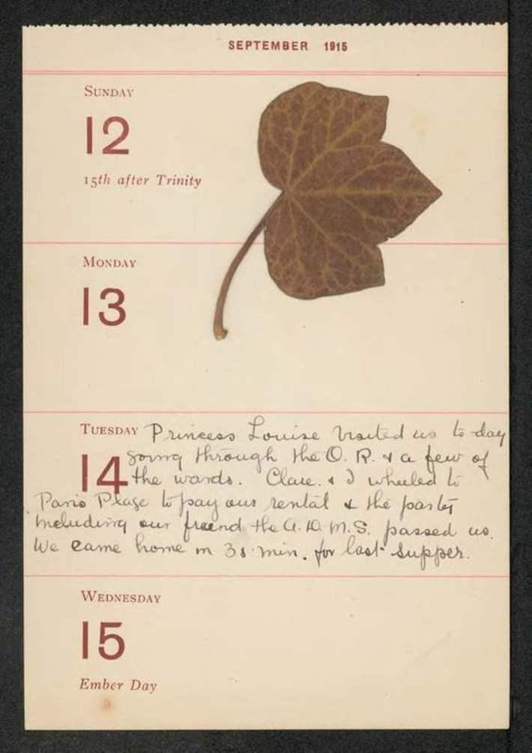

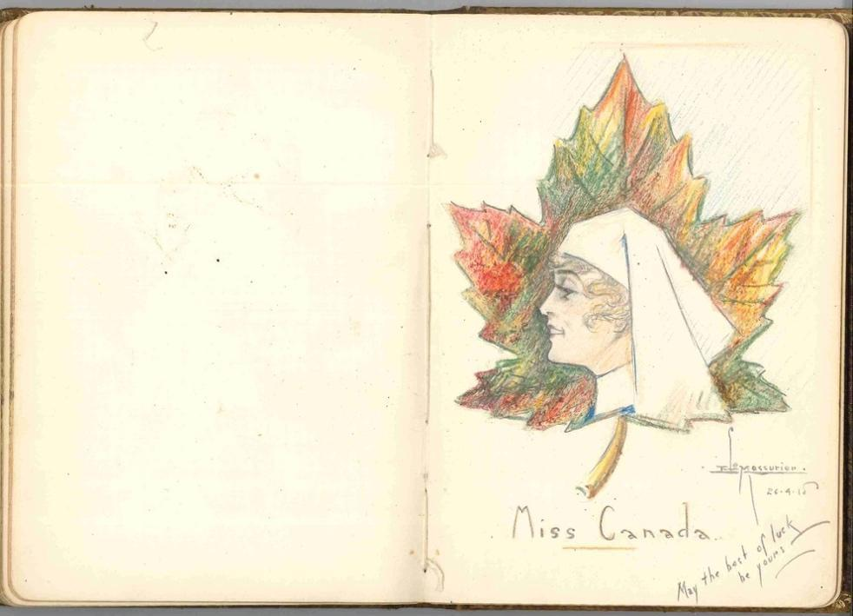
Appendix 2. Inga Johnson, “Inga Johnson Diary 1917-1918,” Operation Canada, page 63.

Appendix 3. Inga Johnson, “Inga Johnson Diary 1917-1918,” Operation Canada, page 87.

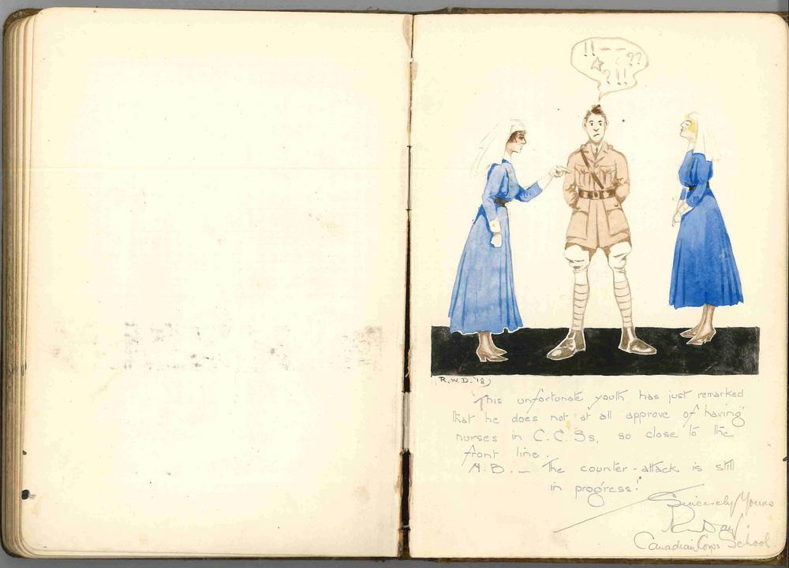

Appendix 4. Clare Gass, The War Diary of Clare Gass, ed. Susan Mann, pgs. 176-177.

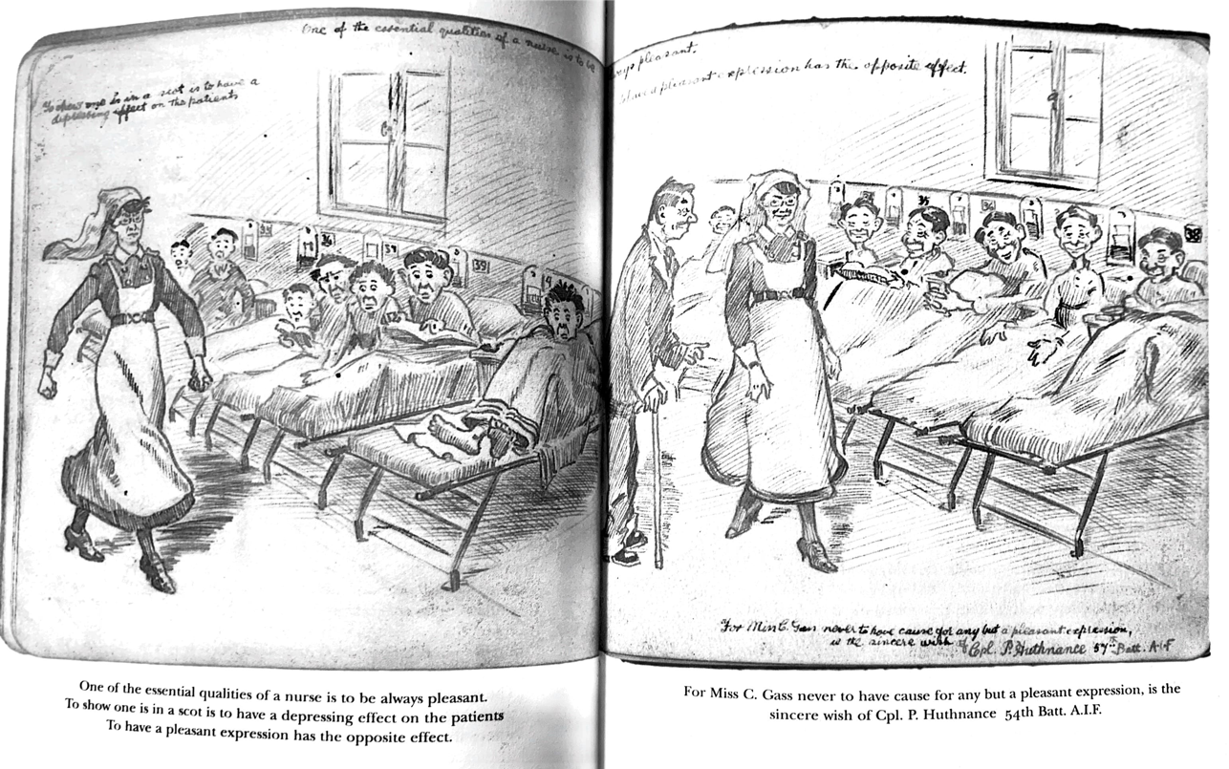

Appendix 5. Inga Johnson, “Inga Johnson Diary 1917-1918,” Operation Canada, pages 31-32.
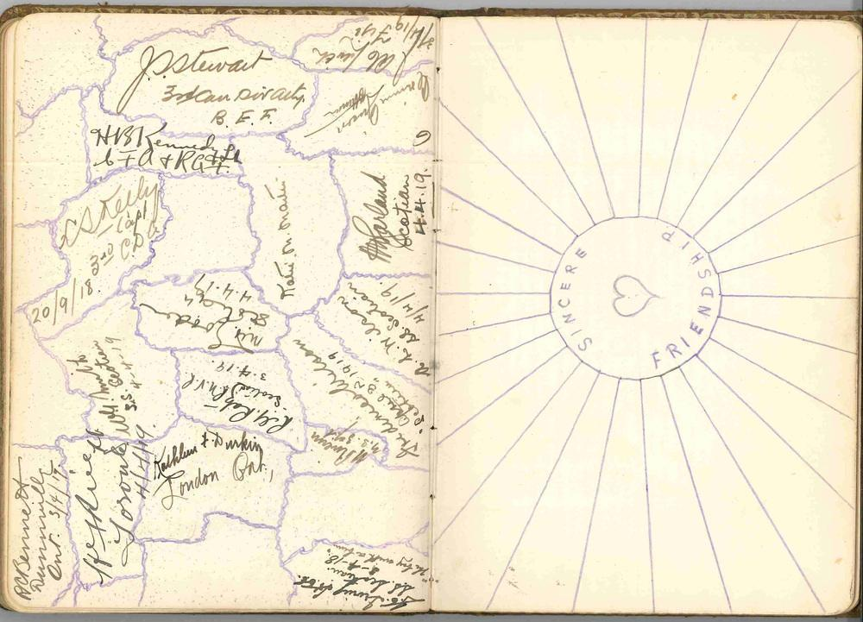

Bibliography

Primary Sources

Bongard, Ella Mae. Nobody Ever Wins a War: The World War I Diaries of Ella Mae Bongard, R.N. Edited by Eric Scott. Ottawa: Janeric Enterprises, 1997.
Gass, Clare. The War Diary of Clare Gass. Edited and introduced by Susan Mann. Montreal: McGill-Queen’s University Press, 2000.
Johnson, Inga. Diary of Inga Johnson. ca. 1917–19. Blue ink on white paper. Unpublished manuscript, 1 volume, 100 pages, 18.5 x 13 cm. George Metcalf Archival Collection, Canadian War Museum Archives, Ottawa, 20160490-001. https://wardiaries.ca/s/operationcanada/page/inga-johnson-1917-1918#?c=&m=&s=&cv=&xywh=-423%2C-123%2C3895%2C2444
Loggie, Ruth. The War Diary of Ruth Loggie, May 1916 to November 1916. Pencil on white paper with pressed leaves. Unpublished manuscript, 1 volume, 101 pages. Ruth Loggie fonds, Provincial Archives of New Brunswick, Fredericton, MC4183. https://wardiaries.ca/s/operationcanada/page/ruth-loggie-1915-1916#?c=&m=&s=&cv=&xywh=-522%2C-75%2C2362%2C1482
Monture, Edith Anderson. Diary of a War Nurse. Edited by Terry L. Monture Wicks. Toronto: Modern Literature and Culture Research Centre, 1996. https://wardiaries.ca/s/operationcanada/page/charlotte-edith-monture

Secondary Sources

Carter, Kathryn. “Introduction.” in The Small Details of Life: Twenty Diaries by Women in Canada, 1830-1996. Edited by Kathryn Carter, 3-29. Toronto: University of Toronto Press, 2002.
Cook, Tim. “’I will meet the world with a smile and a joke:’ Canadian Soldiers’ Humour in the Great War.” Canadian Military History 22, no. 2 (2013): 48-62.
Dodd, Dianne. “Canadian Military Nurse Deaths in the First World War.” Canadian Bulletin of Medical History 34, no. 2 (2016): 327-363.
Fell, Alison S. and Christine E. Hallet, eds. First World War Nursing: New Perspectives. New York: Routledge, 2013.
Gammel, Irene. “’We are the Dead’: rhetoric, community and the making of John McCrae’s iconic war poem.” First World War Studies (2018): 1-18.
Hallet, Christine E. Containing Trauma: Nursing Work in the First World War. Manchester: Manchester University Press, 2009.
Hallet, Christine E. “’Emotional Nursing:’ Involvement, Engagement, and Detachment in the Writings of First World War Nurses and VADs.” in First World War Nursing: New Perspectives. Edited by Alison S. Fell and Christine E. Hallet. New York: Routledge, 2013, 87-102.
Higonnet, Margaret. “All Quiet in No-Woman’s Land.” in Gendering War Talk. Edited by Miriam G. Cooke and Angela Woollacott. Princeton: Princeton University Press, 1993.
Horne, John. “The living.” in The Cambridge History of the First World War. Edited by Jay Winter. Cambridge University Press, (2014): 592-617.
Hynes, Samuel. The Soldiers’ Tale: Bearing Witness to Modern War. New York: Penguin Books, 1997.
Mann, Susan. “Introduction.” in Clare Gass. The War Diary of Clare Gass. Edited and introduced by Susan Mann. Montreal: McGill-Queen’s University Press, 2000.
Mann, Susan. “Where Have All the Bluebirds Gone? On The Trail of Canada’s Military Nurses, 1914-1918.” Atlantis 26, no. 1 (2001): 35-44.
Moser Jones, Marian. “American Nurses in World War I.” PBS. https://www.americannursinghistory.org/military-nurses-in-wwi
Operation Canada. “Inga Johnson.” https://wardiaries.ca/s/operationcanada/page/inga-johnson.
Quiney, Linda J. “Assistant Angels: Canadian Voluntary Aid Detachment Nurses in the Great War.” Canadian Bulletin of Medical History 15 (1998): 189-206.
Quiney, Linda J. “’Sharing the Halo’: Social and Professional Tensions in the Work of World War I Canadian Volunteer Nurses.” Journal of the Canadian Historical Association 9, no.1 (1998): 105-124.
Quiney, Linda J. This Small Army of Women: Canadian Volunteer Nurses and the First World War. Vancouver: UBC Press, 2017, 7-9.
Scott, Eric. “Foreword,” in Nobody Ever Wins a War: The World War I Diaries of Ella Mae Bongard, R.N., edited by Eric Scott, (Ottawa: Janeric Enterprises, 1997), i-v.
Toman, Cynthia. Sister Soldiers of the Great War: The Nurses of the Canadian Army Medical Corps. Vancouver: UBC Press, 2016.
Watson, Janet K. “A Sisters War: The Diaries of Alice Slythe.” in First World War Nursing: New Perspectives. ed. Alison S. Fell and Christine E. Hallet. New York: Routledge, 2013, 103-122.

Edith Anderson Monture, “Charlotte Edith Monture Diary 1918-1919,” Modern Literature and Culture Research Centre, https://wardiaries.ca/s/operationcanada/page/charlotte-edith-monture, 30
Monture, “Diary,” 5.
Eric Scott, “Foreword,” in Nobody Ever Wins a War: The World War I Diaries of Ella Mae Bongard, R.N., ed. Eric Scott, (Ottawa: Janeric Enterprises, 1997), i-v. Ella Mae Bongard attended nursing school in New York at the Presbyterian Hospital which may be why she became a nurse for the United States.
Diane Dodd, “Canadian Military Nurse Deaths in the First World War,” Canadian Bulletin of Medical History 34, no. 2 (2016): 329.
Linda J. Quiney, “Assistant Angels: Canadian Voluntary Aid Detachment Nurses in the Great War.” Canadian Bulletin of Medical History 15 (1998): 191.
Marian Moser Jones, “American Nurses in World War I,” PBS, https://www.americannursinghistory.org/military-nurses-in-wwi
See Susan Mann, “Where Have All the Bluebirds Gone? On The Trail of Canada’s Military Nurses, 1914-1918,” Atlantis 26, no. 1 (2001): 35-44.
See Christine E. Hallet and Alison S. Fell, “Introduction,” in First World War Nursing: New Perspectives, ed. Alison S. Fell and Christine E. Hallet, (New York: Routledge, 2013), 3-4.
In her work Sister Soldiers of the Great War, Cynthia Toman uses the terminology of “soldier” and “soldiering” when describing the work and experience of CAMC nurses.
See Irene Gammel, “’We are the Dead’: rhetoric, community and the making of John McCrae’s iconic war poem,” First World War Studies (2018): 1-18.
Hallet and Fell, “Introduction,” 3.
Ibid, 3-4.
Ibid, 3-4.
Linda J. Quiney, This Small Army of Women: Canadian Volunteer Nurses and the First World War (Vancouver: UBC Press, 2017), 7-9.
See Linda J. Quiney, “’Sharing the Halo’: Social and Professional Tensions in the Work of World War I Canadian Volunteer Nurses,” Journal of the Canadian Historical Association 9, no.1 (1998): 105-124, and Christine E. Hallet “’Emotional Nursing:’ Involvement, Engagement, and Detachment in the Writings of First World War Nurses and VADs,” in First World War Nursing: New Perspectives, ed. Alison S. Fell and Christine E. Hallet, (New York: Routledge, 2013), 87-102.
Mann, “Where Have All the Bluebirds Gone?” 35-44.
Mann, “Where Have All the Bluebirds Gone?” 38-39.
Ibid, 39.
For example, see Ella Mae Bongard, Nobody Ever Wins a War: The World War I Diaries of Ella Mae Bongard, R.N., ed. Eric Scott, (Ottawa: Janeric Enterprises, 1997), 35. Here Bongard refers to British nurses as sisters.
See Mann “Where Have All The Bluebirds Gone?” 38-40, and Cynthia Toman, Sister Soldiers of the Great War: The Nurses of the Canadian Army Medical Corps, (Vancouver: UBC Press, 2016), 75.
Kathryn Carter, “Introduction.” in The Small Details of Life: Twenty Diaries by Women in Canada, 1830-1996, ed. Kathryn Carter (Toronto: University of Toronto Press, 2002), 19.
Carter, “Introduction,” 23-24.
Toman, Sister Soldiers of the Great War, 19-20.
Ibid, 42-44. It should be noted here as well that there were considerable barriers in accessing the education requirements for enlistment with CAMC, which excluded Indigenous women and women of colour. See Toman, Sister Soldiers of the Great War, 55.
Scott, “Foreword,” i-v.
Monture, “Diary,” 11
Operation Canada, “Inga Johnson,” https://wardiaries.ca/s/operationcanada/page/inga-johnson.
Toman, Sister Soldiers of the Great War, 183-187.
Operation Canada, “Ruth Loggie,” https://wardiaries.ca/s/operationcanada/page/ruth-loggie, and Mann, “Introduction,” xx.
Toman, Sister Soldiers of the Great War, 17.
Toman, Sister Soldiers of the Great War, 147-48 and Margaret Higonnet, “All Quiet in No-Woman’s Land,” in Gendering War Talk, ed. Miriam G. Cooke and Angela Woollacott, (Princeton: Princeton University Press, 1993), 206-208.
Samuel Hynes, The Soldiers’ Tale: Bearing Witness to Modern War, (New York: Penguin Books, 1997), 26. Hynes terms the grotesque, realistic manner, in which soldier’s describe the dead (soldiers and civilians), victims, and horror they witnessed in their personal writings, as constituting a “Battlefield Gothic.” Hynes finds the term“Battlefield Gothic” is necessitated by the insufficiency of the term “realism.” “Battlefield Gothic,” goes beyond a realistic description of violence, it conveys a certain reality. (26)
See Christine E. Hallet, Containing Trauma: Nursing Work in the First World War, (Manchester: Manchester University Press, 2009).
Clare Gass, The War Diary of Clare Gass, ed. Susan Mann, (Montreal: Queens University Press, 2000), 32.
Gass, War Diary, 66.
For example, see Bongard, Nobody Ever Wins A War, 35, where she writes of “convoy of 400 terribly wounded cases.” See also Gass, War Diary, 129, , where she references “bad wounds.”
Gass, War Diary, 88.
Bongard, Nobody Ever Wins A War, 52.
Ibid, 22 and 29.
Ibid, 22, 23, and 29. Entries that discuss some of Bongard’s feelings about her patients and sympathy for their suffering
Monture, “Diary,” 27
Gass, War Diary, 60, 62, 69, and Bongard, Nobody Ever Wins A War, 20. Entries on these pages all refer to types of wounds with very little description.
See Bongard, Nobody Ever Wins A War, 16, 23, 27 and Toman, Sister Soldiers of the Great War, 129 for a description of the Dakin tube method for cleaning and irrigating wounds.
Bongard, Nobody Ever Wins A War, 33, 35, 37, 39 have entries that refer to cases of shell shock, or gas related injury.
Ruth Loggie, “Ruth Loggie Diary 1915-1916,” Operation Canada, https://wardiaries.ca/s/operationcanada/media/2263, entry from July 2, 1915.
Bongard, Nobody Ever Wins A War, 20 and 28. See also Monture, “Diary,” 24 and 26-27, where she reports nothing interesting or unusual happened when she was on duty.
For example, Monture, “Diary,” 20-22 and Bongard, Nobody Ever Wins A War, 15 and 18.
Monture, “Diary,” 25
For example, see Gass, War Diary, 47, 51, 56, and 58, with entries on the various activities that her and Ruth engaged in on off days or half days.
See Appendix 1 and Operation Canada, “Ruth Loggie Diary, 1915-1916,” images 10-18
For example, see Monture, “Diary,” 23
Bongard, Nobody Ever Wins A War, 31, 33
Ibid, 38
Monture, “Diary,” 26
See Hallet, Containing Trauma, passim.
Gass, War Diary, 90, 92, 95, 153. Entries describe various times spent going out with patients for golfing and other activities.
Ibid, 59.
Bongard, Nobody Ever Wins A War, 17.
Ibid, 2 and 26.
See Operation Canada, “Inga Johnson Diary 1917-18.” https://wardiaries.ca/s/operationcanada/page/inga-johnson-1917-1918#?c=&m=&s=&cv=&xywh=-423%2C-123%2C3895%2C2444.
See Appendix 2.
See Appendices 3 and 4. For an in-depth discussion of soldier’s humour and slang in WWI, see Tim Cook, “’I will meet the world with a smile and a joke:’ Canadian Soldiers’ Humour in the Great War.” Canadian Military History 22, no. 2 (2013): 48-62.
See Hallet, “Emotional Nursing,” 99.
Ella Mae Bongard, “Untitled Poem,” in Nobody Ever Wins a War: The World War I Diaries of Ella Mae Bongard, R.N., edited by Eric Scott, (Ottawa: Janeric Enterprises, 1997), 70.
Bongard, Nobody Ever Wins A War, 17. Bongard would express anti-German sentiment again, beginning one entry with: “The Kaiser’s Birthday! May he never have another one!” See pg. 29.
Bongard, Nobody Ever Wins A War, 24
Monture, “Diary,” 28-29.
Gass, War Diary, 169
See John Horne, “The living,” in The Cambridge History of the First World War, ed. Jay Winter (Cambridge University Press, 2014), 592-617.
Gass, War Diary, 87 and 141
See Higonnet, “Not So Quiet in No-Woman’s Land,” 213. Higonnet posits that the reason that nurses knew very little about the war effort was because of “the lack of news from the capital; the wartime fragmentation of institutions that disrupts communication lines and generates partial images of the fighting.”
See Hynes, A Soldiers Tale, 31-73.
Janet K. Watson, “A Sisters War: The Diaries of Alice Slythe,” in First World War Nursing: New Perspectives, ed. Alison S. Fell and Christine E. Hallet, (New York: Routledge, 2013), 104.
Gass, War Diary, 154.
See Gass, War Diary, 76, and Susan Mann, “Appendix 5,” in The War Diary of Clare Gass.
For examples of poetry inclusions see, Gass, 11, 13, 78-9, 86-7, 117-18.
One poem Clare Gass writes in her diary is a poem by Henry Johnstone about sleep. Clare would write it after an entry in which she describes having trouble sleeping. Gass, 95.
See Appendix 5.

