An Examination and Analysis of an Unlabeled Artifact in the University of Alberta’s W.G. Hardy Classics Museum

Abstract:
In one of the display cases at the University of Alberta’s W.G. Hardy Classics Museum is a remarkably intact, but unlabeled and unnumbered, classical artifact. This artifact, while rather basic in painting and design, is nonetheless unique and offers intriguing questions as to its contextual origins. The purpose of this paper is to offer an examination and analysis of this artifact. This will be accomplished by first exploring the artifact’s shape and artistic features. Then, both the age as well as the most probable geographical location of production of the artifact will be explored. Finally, a speculation regarding the artifact’s usage, deposition, and purpose will be offered. While the primary goal of this paper is to simply identify the artifact, through the artifact’s examination and analysis, the value of the artifact will be realized not as a somewhat basic classical ceramic lacking in fine details or pomp, but rather as a unique artifact with rich contextual origins that offers us some insights into the cultural extent of Greek colonization in Magna Graecia.

The primary goal of this paper is to confront the issues of artifact context within Classics museums by providing an identification of, and some contextualisation for, an unlabelled artifact on display at the University of Alberta’s W.G. Hardy Classics Museum. As such, the following will seek to profile, date, and draw a framework for the contextualisation of the artifact. This framework for contextualisation will be accomplished through a close examination and analysis of three fundamentally distinctive aspects of the Hardy Museum’s artifact, which are as follows. First, a physical description of the artifact, including scale, material, paintings, alterations, as well as an identification of the shape. Then, the relative date, the geographical location, and the context in which the artifact was used and deposited will be examined. Finally, a brief discussion of the painted depictions found on the artifact's surface will be contemplated. Taken together, these three distinctive aspects will expose the most probable contextual origins of the artifact as well as the artifact’s importance to the cultural extent of Greek colonization in Magna Graecia.
Considering the appearance of the artifact on display at the W.G. Hardy museum, the artifact is quite basic in relation to others in the museum. While I was unable to view the artifact outside of the museum’s display, it is roughly five inches in diameter at the body, and roughly about four inches in height. Given those dimensions, the artifact is not particularly large for Ancient Greek pottery, and certainly not monumental. Additionally, it is clearly composed of a terracotta-type material without any visibly large inclusions, which is evident in surface areas around the bottom, the handle, and the lip, where through handling and use the paint has either chipped away or been worn through. The terracotta material itself is a uniform light reddish-brown colour with four additional colours have been used for the painting of features. The secondary features on the artifact, consisting of symmetrical vegetative tendrils as well as decorative lines and dots, have been painted in a combination of white and gold. The central figure, either a human or a deity, which composes the primary feature, is done with white for the flesh and gold for the hair. Lastly, the wings surrounding the figure are painted using a combination of reddish-brown, white, and gold. Taken together the artifact presents as a relatively small piece of ceramic with a simple colour palette, but with the use of contrasting colours meant to draw the viewer's attention towards the central figure that composes the primary feature.
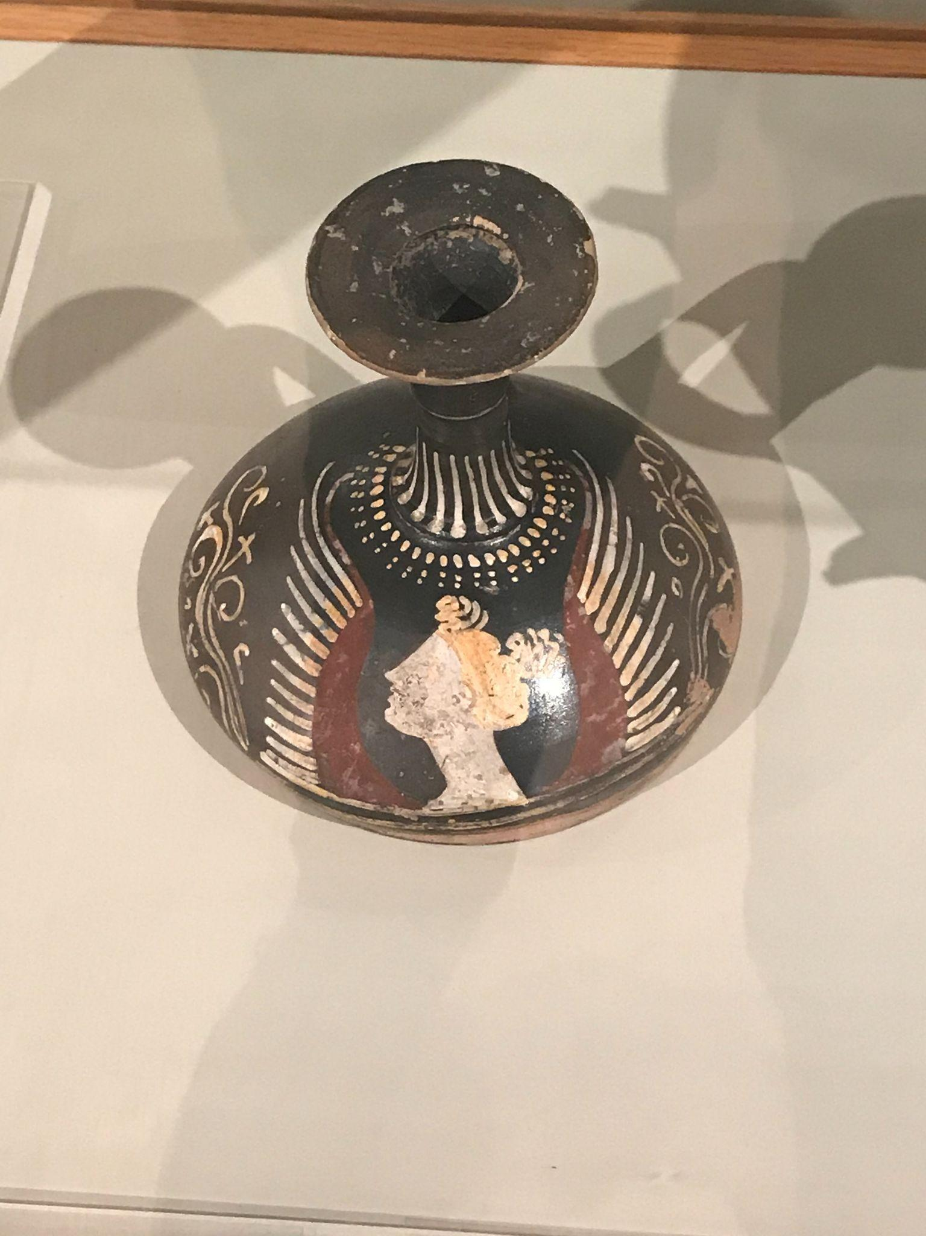
Fig. 1. Front profile of the unlabeled Hardy Museum artifact.
Fortunately, the artifact appears to be whole and not missing any major components including any plastic attachments. If any pieces are missing, it may have possibly once had a plug for the neck, which has since either been separated from the artifact or degraded due to being constructed from a biodegradable material. Furthermore, the state of paint preservation is also quite remarkable, with no signs of a major restoration, and possibly only minor repairs to the paint done if any restoration work at all has been performed.
Identifying the artifact's shape proved to be a unique challenge and the most difficult part of this study. Upon first inspection of the artifact, it appeared as if it may have been a type of askos (Fig. 2.). However, a type III askos, the closest askos resembling the Hardy artifact, is both belly-handled and more globular in shape. The artifact is much flatter than globular in the body and is neck-handled, although the connection of the plastic handle remains fairly low on the neck. A photograph of a lekythos artifact from A.D. Trendall and Alexander Cambitoglou, both fundamental and well-established authorities in art history and classical archaeology, respectively, dispels these differences and much more closely resembles the W.G. Hardy artifact (Fig. 4.). The photograph can be observed in the Second Supplement to The Red-Figured Vases of Apulia Part II (Fig. 3.) and when considering the shape of the Hardy Museum’s artifact, only a small difference in the foot of the two artifacts are obvious. Through a comparison of these two artifacts then, it can be clearly concluded that the W.G. Hardy artifact is indeed a flat-bottomed squat lekythos.

Fig. 2. Comparison of askoi shapes/types.
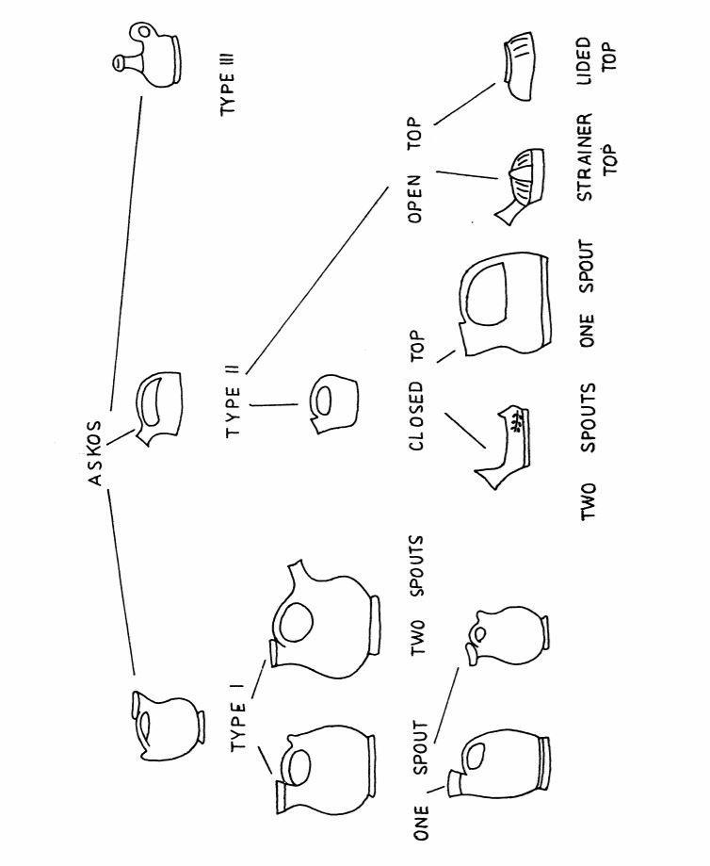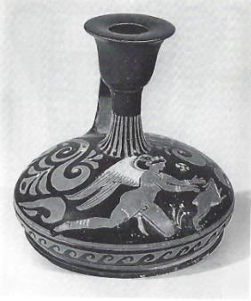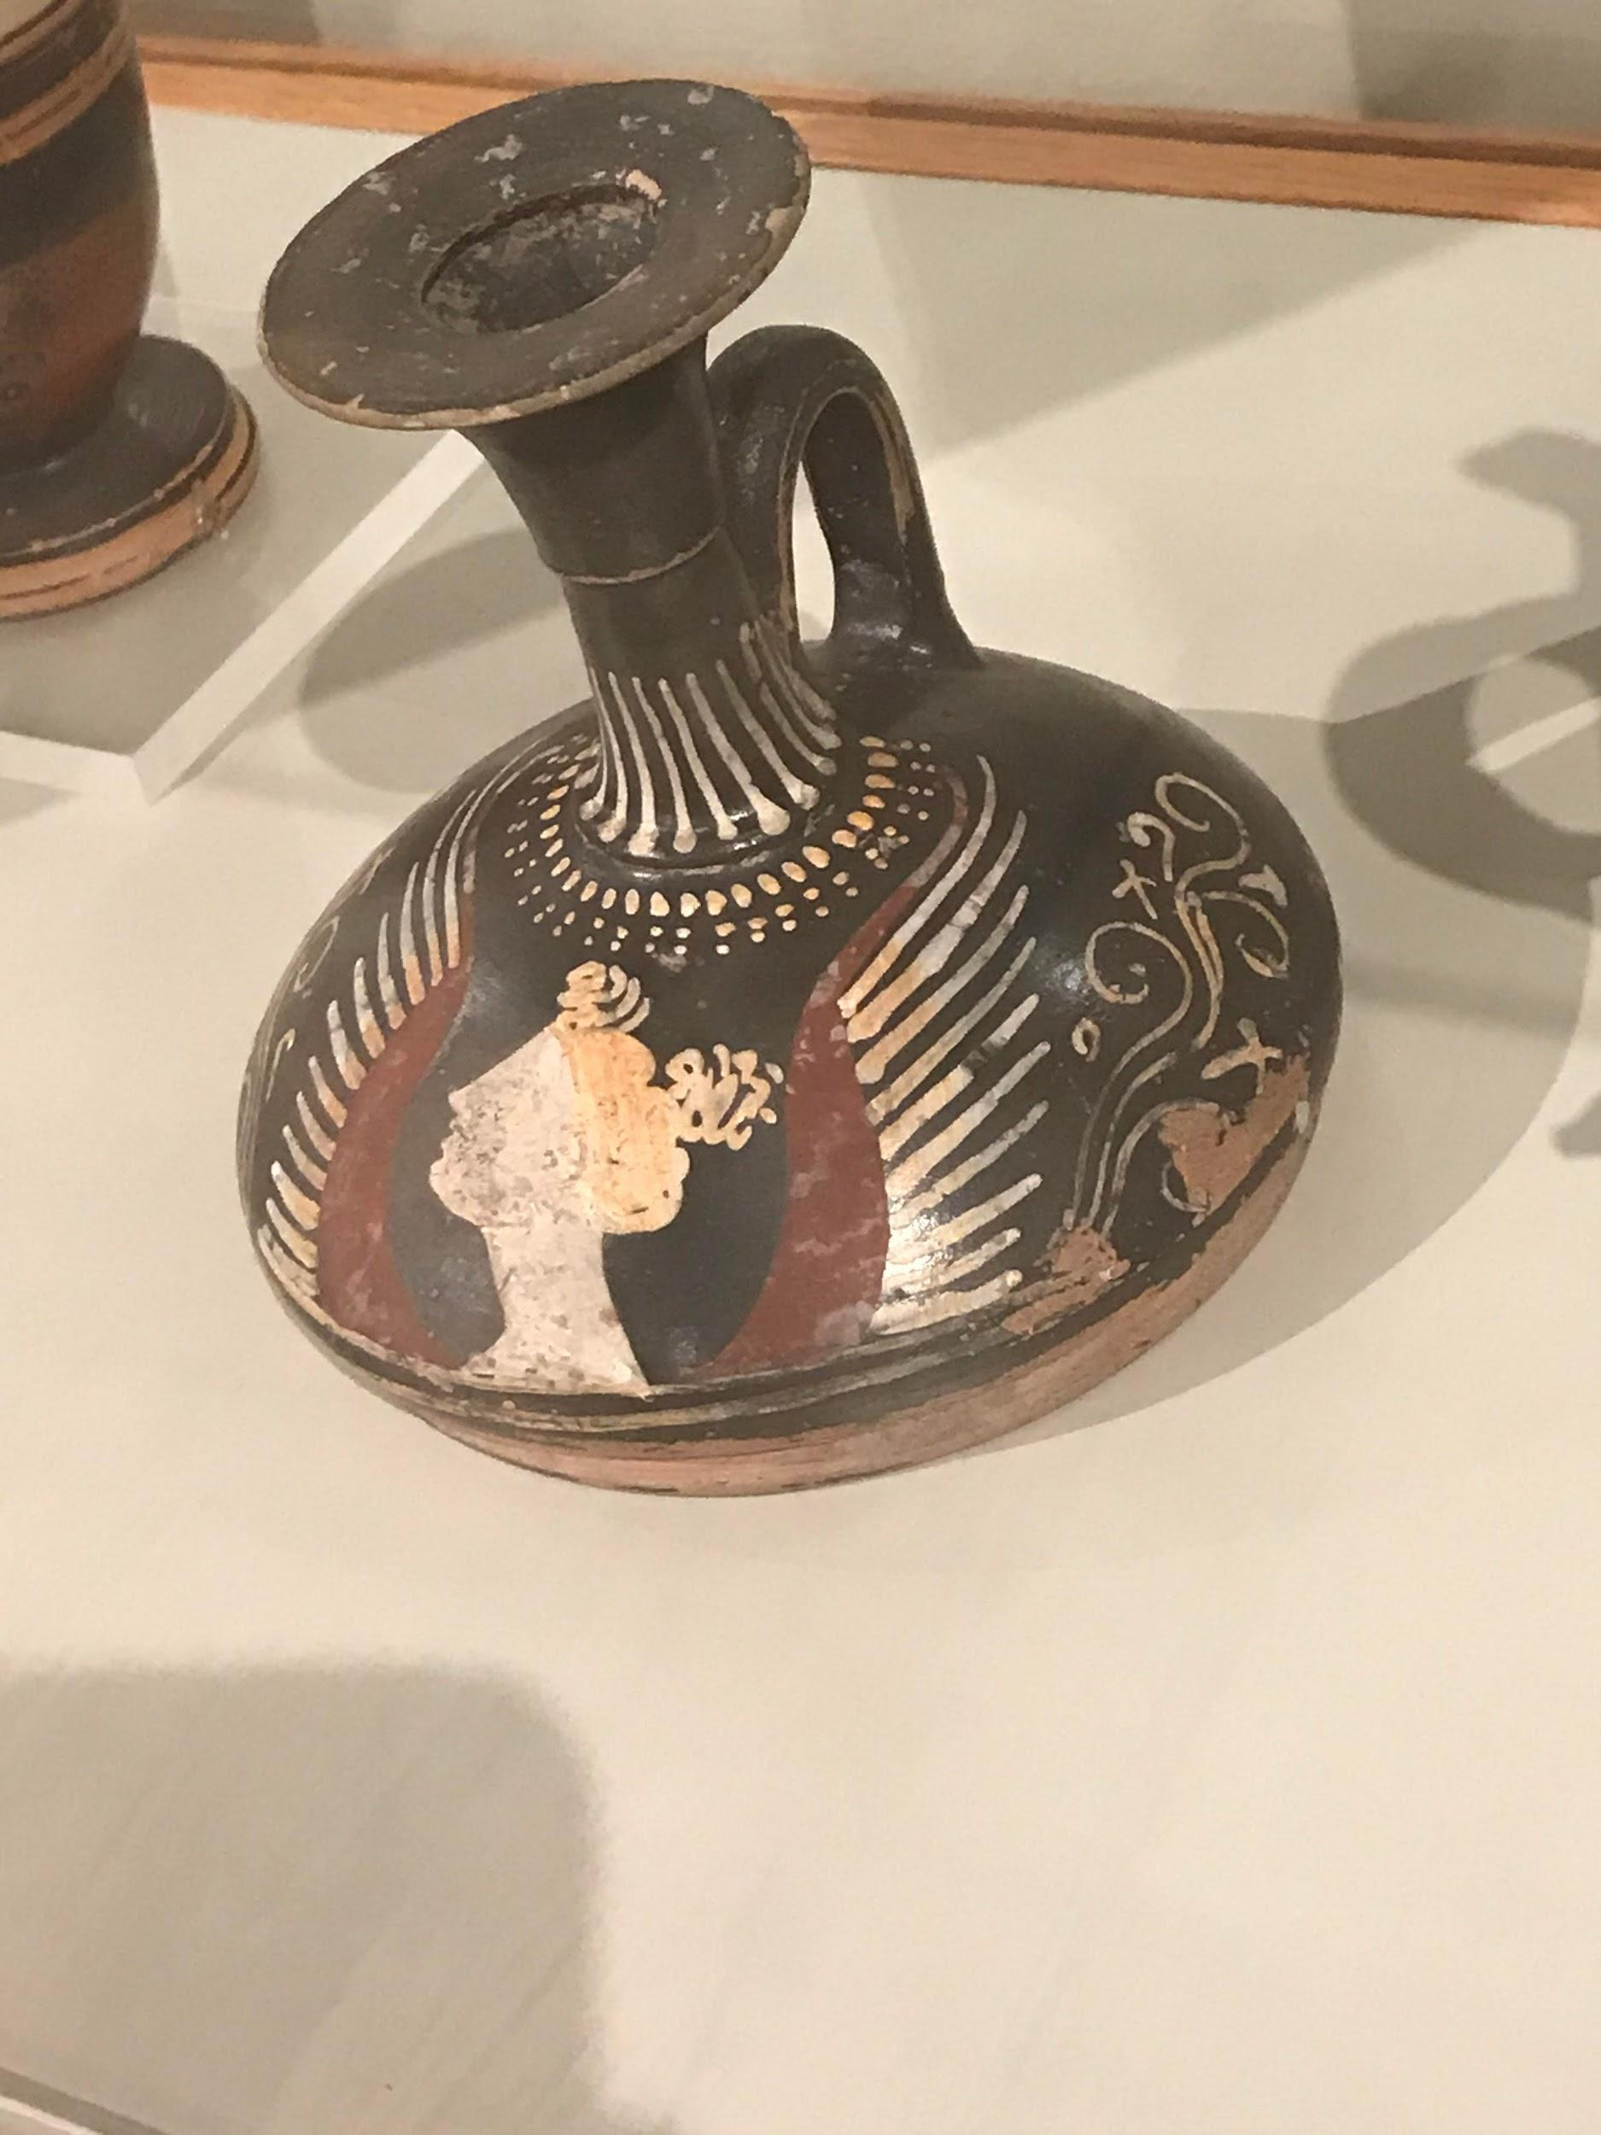
Fig. 3. A flat-bottomed lekythos. Fig. 4. Side profile of the unlabeled Hardy Museum artifact.

The challenge necessitating this study and impeding our understanding of the Hardy Museum’s lekythos is the lack of information regarding the context in which it was found, since no information label has been provided for the artifact in the museum. Since no label is available, our knowledge of the location, the date, and the context in which the lekythos was recovered is limited and allows for various perspectives. Despite this limitation, however, a general consensus regarding the artifact's geographical origin is possible by relying on the most defining feature of the lekythos, the isolated head which serves as the primary feature. Specifically, there are two main subtypes of Apulian pottery, based upon painting styles. Those subtypes are the ornate and the plain subtype. The Hardy Museum’s lekythos is easily identifiable as the plain subtype since the artifact’s painting style features repetitive and simple designs. Furthermore, Richard T. Neer, the William B. Ogden Distinguished Service Professor in Art History at the University of Chicago, states that from c.350 BCE onwards, this distinctive style began to incorporate an isolated woman’s head as the default motif.
While the lekythos therefore likely belongs to the Aupulian plain subtype, it is also understood that more than half of the recovered vases from Southern Italy originate in Apulia. Specifically, these ceramics were originally manufactured in Tarentum, which was the major Greek colony in Apulia. Later, however, due to the increasing manufacturing demand for ceramics, additional workshops were also established in the indigenous Italic communities of Ruvo, Ceglie del Campo, and Canosa in Apulia. Considering then that roughly about 60% of Apulian pottery had features representing isolated heads, even more so for the plain subtype, the Hardy Museum’s lekythos is most probably an Apulian ceramic of the plain subtype originating from one of the aforementioned workshop communities in Apulia.
While the incorporation of isolated heads on ceramics certainly occurred outside of Southern Italy at this time, according to Keely Elizabeth Heuer, a specialist of Greek settler and indigenous Italic relations of pre-Roman Italy whose work I draw upon extensively in this paper, it only occurred erratically and infrequently. Furthermore, Heuer states that when isolated heads are recovered on pottery from this time outside Southern Italy, they can usually even be traced back to a specific workshop. For instance, Athenian artifacts with isolated heads are usually identified through an inscription or another similar attribute, of which neither are visibly discernable on the lekythos as it is presented in the museum. Unlike the Athenian workshops which tended to identify their ceramics with an isolated head , those of Magna Graecia or Greek colonized Southern Italy, tended not to sign or indicate the origins of their creations. Indeed, to date, only one ceramic artifact from Magna Graecia with an isolated head has been found inscribed with a creator. Therefore, from what is visible to the observer at the W.G. Hardy Museum, it is safe to assert that the lekythos most probably originated from a workshop in Greek-colonized Southern Italy.
In regards to the dating of the artifact, it is more difficult to provide an absolute date as it lacks not only a workshop inscription but also feature attributes and does not contain intricate detail in the painting. However, ceramic workshops in Apulia were not manufacturing ceramic works with isolated heads until after 450 to 425 BCE; before then, most isolated heads were usually mythological figures, clearly identified by their markings, and painted on Athenian red-figure pottery. In addition, before 340 BCE, isolated heads were mostly used as secondary features paired with funeral scenes, which is not the case with the Hardy Museum’s artifact as the isolated head comprises the primary feature. According to Heuer, while isolated heads were not frequently painted until roughly 425 BCE the following years, from 340 BCE to 310 BCE, saw the greatest number of ceramic works produced in the Apulia region of Magna Graecia. Furthermore, the bulk of the Apulian pottery produced during these years was produced primarily from two leading workshops: either Darius and Underworld Painters, or the Patera, Ganymede, and Baltimore Painters. Considering these temporal specifications, the Hardy Museum’s artifact can be relatively dated to between 340 to 310 BCE and can be said to have been most probably produced during this ceramic manufacturing boom in one of the aforementioned workshops notable for producing Apulian red-figure pottery.
Given the relative date of 340 to 310 BCE as well as the location of Apulia, what does this mean for the context in which the artifact was likely originally deposited and recovered? Many of the vases of Apulian production contain patterns among them that tether them to a funerary context. Paintings of isolated heads in particular, have served as symbols and representations of the common beliefs surrounding the afterlife. Both of these statements are reinforced in archeological findings as Heuer states that head decorated pottery from Southern Italy is often found within funerary contexts, both within the grave and above it as well. The relatively good physical condition of the Hardy lekythos–such as the fact that it is whole and intact with little missing other than some chips–provides evidence that it was both deposited within and recovered from an undisturbed funerary context. As the Hardy lekythos also lacks fine detailing in the painting, and since the painting is done with obvious imperfections such as crooked lines and asymmetrical dots, it suggests that it would have been produced to be affordable and intended for sale on a mass market. The signature signs of use such as the chipping of paint around the rim, the handle, as well as the base, speak to the likelihood that the artifact was used practically before it was designated to be deposited within a funerary context.
In order to comprehensively understand the context, the significance, and the practical use of the Hardy lekythos it is important to examine its primary feature, the isolated head surrounded by wings. Upon an initial inspection, it appears as though that the isolated head on the Hardy lekythos may have been intended to be a depiction of the deity Eros, because Eros is a rather popular subject depiction in Apulian pottery, who was depicted with wings. In comparison to the goddess Nike, However, Eros is a more frequent full-length figure depiction on Southern Italian pottery, whereas on the Hardy lekythos the primary feature is an isolated head. Eros is also a male deity and the isolated head of the artifact clearly shows feminine features including long hair that is seemingly being contained in a kekryphalos. Cross-examining both figures 4 and 5 as compared to the isolated head on the Hardy lekythos, one can clearly discern the similarities in the depictions of Nike in similar Apulian pottery, and the isolated head depicted on the Hardy Museum’s artifact. In the above figures 4, 5, and 6, the resemblance to Nike can likewise be observed through the use of white colouring for skin, the use of white-gold colouring for hair, as well as through the representation of the wings which are depicted containing individual feathers.
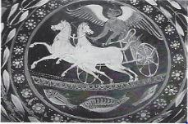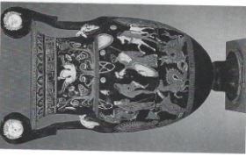
Fig. 5. Nike driving. Fig. 6. Possibly a winged Nike isolated head.

Regardless of these striking similarities, it is still difficult to absolutely distinguish isolated female heads from other full-length depictions–including both depictions of deities as well as mortals–making the task of distinguishing isolated heads on Southern Italian pottery almost impossible. However, the aforementioned scholar Cambitoglou states the following:

I interpret the heads between two wings as abbreviations of a Nike, but the feminine features of these heads cannot be decisive in the matter, and the possibility that they may be abbreviated representations of Erotes of the hermaphrodite type, so frequent in this period, cannot be excluded altogether.

It is clear that while distinguishing the correct identities of isolated heads on Apulian pottery is a near impossible task, there are still differences in their depiction which lend themselves to a more plausible identification. In the context of the Hardy Museum’s artifact, I agree with Cambitoglou in that the artifact’s isolated head is probably that of the goddess Nike, but that it is still possible the isolated head may be a depiction of a hermaphroditic Eros. Provided that the isolated head is probably that of Nike, it can be speculated that the Hardy lekythos may have either been gifted to, used by, or deposited into the grave of an athlete. Nike being the personification of victory, it would be the most appropriate depiction of a deity to find on a lekythos vessel which would have stored oil, particularly the perfumed bathing oil of an athlete. It needs to be mentioned, however, that this analysis remains purely speculative in the absence of direct concrete evidence to support the correlation.
In conclusion, upon a close examination and analysis of the W.G. Hardy Museum’s artifact, a few specific conclusions can be drawn surrounding the artifact's context, use, and significance. Considering the artifact’s primary and secondary features, material, shape, as well as particular aspects of the artifact, such as it being neck-handled, the artifact presents itself unquestioningly as a flat-bottomed squat lekythos. Regarding a geographical location, the artifact presents as a red-figure Apulian ceramic in the plain style, possibly having been produced from a workshop in the communities of either Tarentum, Ruvo, Ceglie del Campo, or Canosa. The artifact’s relative date can be roughly estimated to be from between 340 to 310 BCE, and due to the wear patterns present, it is likely to have been briefly used before it was designated to later be buried within a funerary context.
While identifying particular isolated heads presents unique challenges, this is especially true for Apulian artifacts as they are rarely signed or inscribed. However, it can be discerned that the figure presented on the artifact as the primary feature is most likely that of the goddess Nike, but it could also be a depiction of hermaphroditic Eros. However, despite this paper’s intention to avoid drawing a broader conclusion and to instead simply focus on identifying the artifact, a wider conclusion has become evident. Regardless of the identity of the deity and the possibility of the artifact belonging to an athlete, the investigation of the artifact nonetheless points to the scale of Greek colonization in Magna Graecia from about 400 to 300 BCE. Through the investigation of the W.G. Hardy Museum’s artifact, it is apparent that during this time, Greek colonization in pre-Roman Magna Graecia existed to an extent that there was at least a market for Greek-styled squat lekythoi which were mass-produced and likely intended to be used in contexts such as sporting and funerals. athletic and or funerary contexts.

Bibliography

Cambitoglou, Alexander. “Groups of Apulian Red-Figured Vases Decorated with Heads of Women or of Nike.” The Journal of Hellenic Studies 74 (1954): 111-121.
Heuer, Keely. “The Five Wares of South Italian Vase Painting.” December, 2010. https://www.metmuseum.org/toah/hd/five/hd_five.htm.
Heuer, Keely. “Vases With Faces: Isolated Heads in South Italian Vase Painting.” Metropolitan Museum Journal 50 (2015): 62-91.
Kohoutková, Jindra. “An Apulian Askos in Prague.” Listy Filologicke / Folia Philologica 112, no. 2 (1989): 81-85.
Neer, Richard T. Greek Art and Archeology c.2500 - c.1500 BCE. New York: Thames and Hudson Inc., 2012.
Trendall, A.D., and Alexander Cambitoglou. Second Supplement to the Red-Figure Vases of Apulia Part I. London: University of London, 1992.
Trendall, A.D., and Alexander Cambitoglou. Second Supplement to the Red-Figure Vases of Apulia Part II. London: University of London, 1992.

Jindra Kohoutková, “An Apulian Askos in Prague,” Listy Filologicke / Folia Philologica 112, no. 2 (1989): 85.
A.D. Trendall and Alexander Cambitoglou, Second Supplement to the Red-Figure Vases of Apulia Part II (London: University of London, 1992), PLATE LXVIII.
Richard T. Neer, Greek Art and Archeology c.2500 - c.1500 BCE (New York: Thames and Hudson Inc., 2012), 321.
Neer, Greek Art and Archeology c.2500 - c.1500 BCE, 321.
Keely Heuer, “The Five Wares of South Italian Vase Painting,” December, 2010, https://www.metmuseum.org/toah/hd/five/hd_five.htm.
Heuer, “The Five Wares of South Italian Vase Painting.”
Keely Heuer, “Vases With Faces: Isolated Heads in South Italian Vase Painting,” Metropolitan Museum Journal 50 (2015): 75.
Heuer, “Vases With Faces: Isolated Heads in South Italian Vase Painting,” 64.
Heuer, “Vases With Faces: Isolated Heads in South Italian Vase Painting,” 64.
Heuer, “The Five Wares of South Italian Vase Painting.”
Heuer, “Vases With Faces: Isolated Heads in South Italian Vase Painting,” 66.
Heuer, “Vases With Faces: Isolated Heads in South Italian Vase Painting,” 66.
Heuer, “Vases With Faces: Isolated Heads in South Italian Vase Painting,” 75.
Heuer, “Vases With Faces: Isolated Heads in South Italian Vase Painting,” 75.
Heuer, “The Five Wares of South Italian Vase Painting.”
Heuer, “Vases With Faces: Isolated Heads in South Italian Vase Painting,” 64-65.
Heuer, “Vases With Faces: Isolated Heads in South Italian Vase Painting,” 64-65.
Heuer, “Vases With Faces: Isolated Heads in South Italian Vase Painting,” 72.
Heuer, “The Five Wares of South Italian Vase Painting.”
Heuer, “Vases With Faces: Isolated Heads in South Italian Vase Painting,” 68.
A.D. Trendall and Alexander Cambitoglou, Second Supplement to the Red-Figure Vases of Apulia Part I (London: University of London, 1992), PLATE LXXXVI.
Trendall and Cambitoglou, Second Supplement to the Red-Figure Vases of Apulia Part II, PLATE XXXIII.
Trendall and Cambitoglou, Second Supplement to the Red-Figure Vases of Apulia Part II, 66.
Alexander Cambitoglou, “Groups of Apulian Red-Figured Vases Decorated with Heads of Women or of Nike,” The Journal of Hellenic Studies 74 (1954): 121.

