Rylee Thomson
Women, Ale, and Witchcraft: The Influence of Men on the Brewing Industry and the Perception of Alewives
Men feared the female-dominated brewing industry. More precisely, they feared the autonomy it made possible for women. Historically, women pioneered and monopolized brewing, dating back centuries to the origins of the craft. Their familiar presence coined the terms: Alewives and Brewsters, recognized titles for the women who brewed. By the fourteenth century, drinking had transformed into widespread conventional English behaviour, exponentially growing the demand for brewed Beer and Ale. The investment opportunities of the expanding industry sparked male interest in the women-dominated trade. Men became increasingly aware of what they viewed as inappropriate and dangerous liberties gained by women in this industry. The economic profit earned by women in brewing and tavern-keeping offered them independence outside of marriage and the household, the ability to resist the gender roles set in place by religious beliefs and authority and incite unrest in the male population. Men made their displeasure well known through discrediting and humiliating female brewers and restricting their capacity by enacting laws and regulations. Throughout Britain and its colonies, individuals articulated their discontent through woodcarvings, poems like The Tunning of Elynour Rummyng, anthologies, and legal texts such as The Lawes Resolutions of Womens Rights. Economically prosperous alewives found themselves outside their craft, prosecuted by laws for criminals and witches. By transforming the perception of female brewers and prohibiting their activity, men drove women out of the developing brewing industry, eliminating their threat to society's patriarchal structure and capitalizing on the market without competition.
The traditional role of women in everyday society was taking care of the family, reproduction, maintaining the household, and following the Lord. Successfully managing these matters earned them respect, unlike men who found their status through wealth, work, and social networks. Increase Mather, a New England Puritan clergyman, represented this pride when speaking about his late wife to his children. "Your Dear Mother, did in many things, set an Example before you, worthy to be imitated… You see, Children, what your now Blessed Mothers Prayers & Hopes were for, and concerning you." Men expected women to remain in the household with the family while they went to work. Chores or duties necessitated occasions where women could venture into public society. In social circumstances, women needed to be accompanied by a male companion to avoid a negative perception of the family. In some instances, women could frequent the tavern with their spouses, but "if they accompany their husbands or their kinsmen to the tavern, it is to wait on them respectfully, but not to share their refreshment." In general, women served men, and men saw women as their subordinate companions, as set out by the Christian social structure. Their tasks and responsibilities were designated to preserve the household. As a result, brewing fell into their hands due to the nature of the method and location of the production—the home.
The brewing enterprise began as a domestic process, a good produced in the home. Men found it menial and time-consuming, below their skill competency, and thus deferred it to women. Brewing malt beverages took hours to days and required regular close supervision. The London and Country Brewer accounts this process, describing the numerous steps that took place at different time intervals and required dedicated caution to produce the perfect supply. The process yielded a batch satisfactory for the household, male acquaintances, and local community. Women also managed the purchasing of the alcohol supply and maintained the cellar. For women, it was not designed to give them wealth or achievement but to appease their male companions in other ways. Yet, over time, growing demand outsized these systems. Ale and alehouses grew in popularity in the centuries following the Black Death. Daily household consumption of malts grew by gallons, and brewers had the opportunity to expand their market. Under these pretences, alewives had ample opportunities to gain. Brewing was a woman's craft that now allowed them to pursue financial and social success. However, achieving success in the growing industry would not be possible without significant obstacles for alewives.
Greater demand required Brewsters to increase the scale of their production. The yield of their previous batches limited their supply for sale, and because Ale had a short shelf life, it was necessary to have fresh products available constantly. Alewives needed to invest in more extensive facilities to produce volumes of Ale that consistently satisfied their customers. Regardless, the inability to transport Ale across distances before it spoiled limited commercial growth. Hops created new opportunities for the industrialization of the craft when they were introduced into the brewing trade. Hopped malts, Beer, could be stored for up to a month, a significant increase from Ale, which only lasted one week. Supply consistency was facilitated by this additive, gaining prosperity for Beer brewers that surpassed even the most established Ale producers. Profitability was at its peak, and it was noticeable, with the women who dominated the industry earning more than ever. Men had the assets to invest and began to enter the competition now that the venture was worth their while. Business was booming, and the number of alehouses increased, each attempting to earn from this investment. Estimates calculate that by 1577 in England, there was an alehouse for every 142 inhabitants. Yet men believed the market was not large enough for women and themselves and refused to let them remain in their way.
The obstacle women imposed on men in the industry was more than just financial. Although, the disadvantages of their economic activity are notable. Many Brewsters had established clientele and shrunk the available customer base. Since greater competition forces strategic pricing, sellers had to lower costs to remain competitive and be the most advantageous source to consumers. The reduction in cost price resulted in decreased profit, and the presence of women in the enterprise strained overall sales. However, this was not the threat many men were concerned with. Economically prosperous Brewsters earned an autonomous opportunity. Their position in the industry allowed them to have wealth and own property. In the patriarchal society, this went against the norm. Income, earning, and estate owning were male responsibilities. These roles came with status and influence, as the economic arena dominated England and the colonies. To tolerate women competing in such a wealthy enterprise placed the power dynamic at risk. As Christian populations valued and endorsed the male-controlled structure, this left their very foundation vulnerable.
Likewise, without the necessity of a man to uphold a woman's or family's financials, women could maintain their livelihood. Financial liberty meant women earning income could decide against marriage if they pleased. Society socially constructed the essential need for a husband, and even when women often fulfilled this need, the financial liberation of women risked removing them as a requisite for economic survival. Concurrently, the labour necessary to brew at the growing scale was time-consuming. It took time away from the household and, accordingly, procreation, as women had less time outside of work to prioritize the latter. Brewsters needed to focus on matching the demand of the growing enterprise if they wanted to remain a competitive fixture. Success, in any industry, takes a dedication long attributed to the working husband. The satisfaction of these above pressures could further destroy the established socio-religious traditions, a phenomenon Male leaders countered with resistance and hostility. Duly, men approached this matter with an arsenal of means to eliminate the dangers Women posed to the brewing industry and gender roles. The objective was to push women out of the industry, whether by force, regulations, or indignity. Over centuries, the scale of discontent with Brewsters and tavern-keeping women grew to hatred. Synchronously, the methods employed to drive women out of the enterprise decreased in respect and cordiality. The goal that began with legislative changes in ownership and brew regulations ultimately turned to public scrutiny and prosecution to achieve the aim.
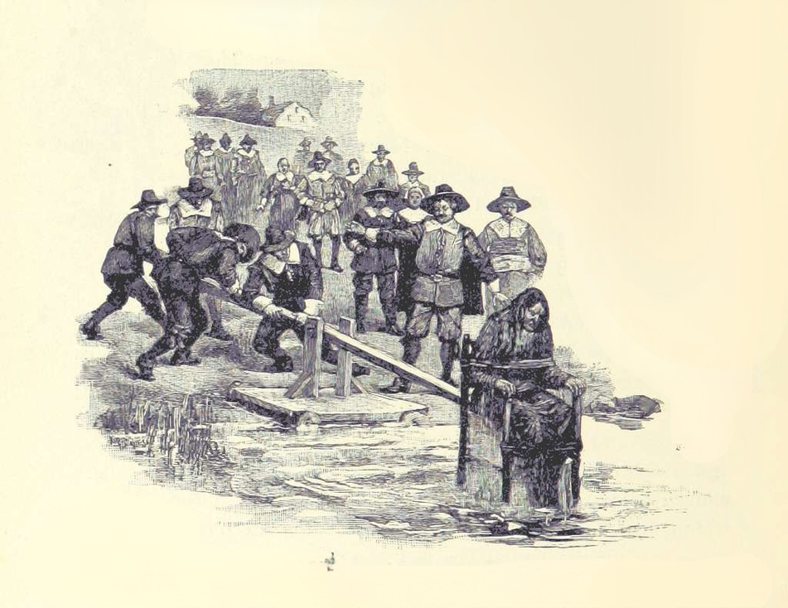
First, women faced higher regulations on brewing than their male competitors. Quality and price were how Brews were regulated. Any infractions, including sour malts or deceitful sales, faced fines, penalties, and punishments. An early example was "giving false measure paid a fine of 4s., and anyone making bad ale was either placed in a cucking-stool or fined 4s." By the 17th century, the cucking stool was the most fateful of women, seen in figure 1. Many records describe the cucking stool as a punishment reserved for women.. The device was comprised of a wooden or iron armchair to which the accused was bound. This chair was affixed to a long wooden beam, typically positioned beside a body of water, and lowered into the water. See figure 1 for an illustration of this public punishment, where women were forcibly dunked as a form of humiliation. The accused individuals were submerged to ascertain their guilt or innocence, with floating interpreted as a sign of witchcraft. Repeated submersions often led to fatal outcomes, either from shock or drowning. This regular punishment was well known, and society shamed women for their behaviour. When published, the following poem intended to instill fear, expecting women to adhere to regulations.
Figure 1. Illustration of a woman subjected to public punishment via a cucking stool, also known as ducking. Edward Eggleston, The Household History of the United States and Its People, for Young Americans (New York: D. Appleton and Company, 1889), 110. Public domain. Courtesy of the Library of Congress.
Hail to you the brewsters with your gallons
Potels and quarts, over all the towns.
Your thumbs bear much away, shame have the trickery;
Beware of the cucking-stool, the lake is deep and dirty.
In places subject to exceptional supervision, women faced the highest regulation and a reduction of their competitive capacity. When fines were used instead of punishments, women found it more challenging to afford the fee. The government profited by taxing brewers; thus, they were obliged to remunerate a share of their revenue. The incidental costs caused a strain on the women expected to earn an income, and expense taxes and fines aggressively sentenced against them. Additionally, their frequent infractions began to repute them as poor or low-quality brewers, offering suspicious or altered malts. Women had the fewest representatives in the Brewers' Gild of London concerning regulation. Considering this, women faced higher rates of regulation and penalties, with men ruling the regulations.
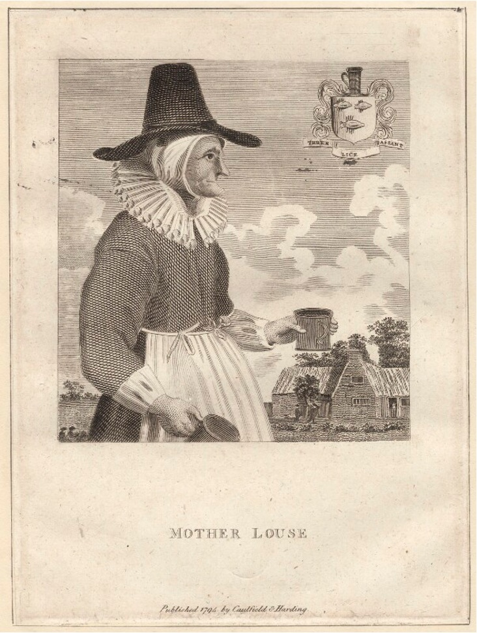
Next, England and the Colonies imposed laws that affected women's ability to control property and wealth. Upon marriage, a woman's property and wealth were passed to her husband, and any earned during the marriage was also to him. For brewers, this meant that their property, skill, and income were not theirs to have or keep. Brewsters had no rights to the alehouses they owned and ran and could not claim their earnings. Men had the opportunity to assert themselves as the head of the brewing establishment their wives had founded. The number of couples grew as the enterprise expanded, as household Brewsters became labourers for their husbands. As husbands caught the focus as successful businessmen, it was only with the skill their wives had been wielding. The colonies based their laws upon those enacted in Britain and maintained this structure. Women handed over their livelihoods to their husbands, and they controlled brewing and alehouse keeping. With further industrialization, husbands could capitalize on the growing industry that was once a task they slated to their wives.
Figure 2. Engraving of Mother Louse, a seventeenth-century innkeeper, depicted holding a jug and tankard outside her establishment, “Louse Hall.” David Loggan, Mother Louse (London, 1650–72). © The Trustees of the British Museum. Image shared under a CC BY-NC-SA 4.0 license.
Those outside of these laws, unmarried brewers, received negative associations. Their labour was the same as that of married Brewsters, providing malts to their customers. Still, they received poor public perception. As mentioned, they went against the model, earning money and evading marriage. Society thought of unmarried Brewsters as spinsters—ugly, undesirable women not worthy or capable of maintaining a family. Shown in figure 2, the woodcarving of the famous Mother Louse is an exemplar of these stereotypes. Her portrait highlights her bumpy and rough profile, with a large nose and chin wrinkled by her aging work. Mother Louse wears her traditional garb, a bonnet and wide-brimmed hat, a neck ruff, and an apron, covered head to toe to shield her from the heat and dirt of the brewing process. As she stands before her alehouse, clutching two steins of her Ale, she lacks femininity and delicacy. The smile on her face depicts a sense of satisfaction, but the satirical print illustrates the artist's displeasure with her look and occupation. Mother Louse is the Alewife's image, which many imagine at the thought. Many said she was beloved by many for her offering, yet she was not exempt from representations of the ugly Brewster. Her portrait only begins the ill imaging of brewing women during this shift, as the vindictive men embrace their increasing repulsion in their graphics.
Beyond spinsters, brewing women had other conflated identities. As taverns and inns became a place to seek prostitutes, many located close to brothels, innkeeping women got tied to prostitution themselves. One cause for this connection was that prostitution supplemented the financial limitations of Brewsters with low income. Their clientele had more than one service they desired, and for many who needed to survive, offering both created a livelihood. Publicly described as "immodest, lascivious, and shameless women' luring men at taverns and alehouses." Nonetheless, only a minority of alehouse keepers and alewives are known to have worked in prostitution, yet this grew a reputation for all.
Another circumstance that produced this definition was women who broke gender roles and attended taverns alone. Any woman who wandered a tavern was assumed to be soliciting for sex, regardless of their intention. Women attended taverns to drink and socialize, breaking social rules, and men refused to view their presence as equivalent. Women in taverns were wrong; thus, they must participate in deviant behaviour. Alehouse keepers and those attending the halls fed men drinks and served their labours. These stereotypes became established in poems and writings and began the wave of compositions that instilled fear of alewives, their halls, and their drink. As the following poem reads:
The fume of the wine
goes straight to the head,
and the body is filled with lust
for human flesh with such great rage that until the next day
they stay with the vile whores.
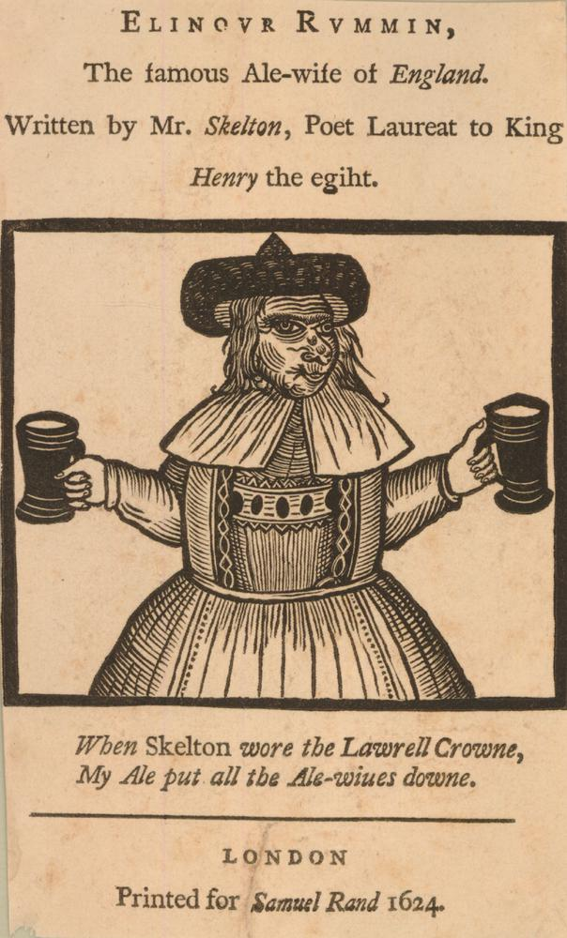
As the public discourse on Brewsters spread, stereotypes stacked on one another: From issues of regulation, their suspicious brew; from their spinster behaviour, their unsightly being; and of the products of their alehouses, associations with prostitution. These vile connotations grew public distaste for women in brewing. A most famous vocalization of this aversion is by John Skelton, speaking on Elynour Rummyng, now one of the most well-known depictions of a Brewster. In his poem, The Tunning of Elynour Rummyng, he details the woman's grotesque features: her old and fat body, saggy skin, hunched spine, hooked nose, gray hair, and bristled face. The woodcarving, figure 3, illustrating her description from the poem, looks strikingly similar to Mother Louse.
Figure 3. Woodcut of Elinour Rummin, shown standing with a mug in each hand. Facsimile of the title-page to John Skelton’s Elinour Rummin (London: 1624); reproduced in Elinour Rummin (London: Anon., 1794). © The Trustees of the British Museum. Image shared under a CC BY-NC-SA 4.0 license.
The poem continues by berating her business, describing her brew as low quality and her behaviour as inappropriate. She participates in trading goods for alcohol and dishonours the Lord by entertaining witches and Jews and speaking profanely. Skelton's words soon become the familiar rhetoric around alehouse women, with one line introducing a new, important accusation. As demeans Elynour Rummying, he states,
And this comely dame,
I understande, her name
Is Elynour Rummynge,
At home in her wonnynge;
And as men say
She dwelt in Sothray,
In a certayne stede
Bysyde Lederhede.
She is a tonnysh gyb;
The devyll and she be syb..
This insertion begins the newest stereotype, one that will significantly support the movement to drive women out of the industry, that Brewsters and Alewives meddle with witchcraft.
The depiction of alewives as witches became a compelling argument in the effort to remove women from the brewing industry. In both England and the colonies, fear of witchcraft was on the rise. People began to suspect their friends, families, and neighbours of witchcraft, hoping to capture all those they believed were corrupting society. This conflation of stereotypes grew, and publications about alewives increasingly linked their behaviour with witchcraft. The merging of these stereotypes profoundly impacted Brewsters, rapidly eroding their autonomy. The economically successful Alewife was seen as "fearful," much like the ordinary witch. For those working to eliminate women from the competition, this stereotype provided a powerful pillar for their argument. As the two identities became more entangled, the Alewife was convicted alongside witches, her image becoming synonymous with those hunted, and her behaviour seen as evidence of witchcraft.
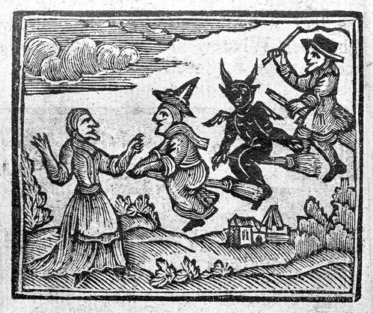
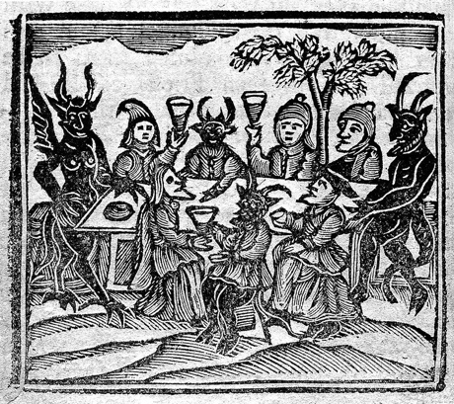
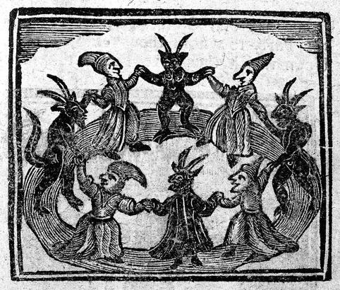
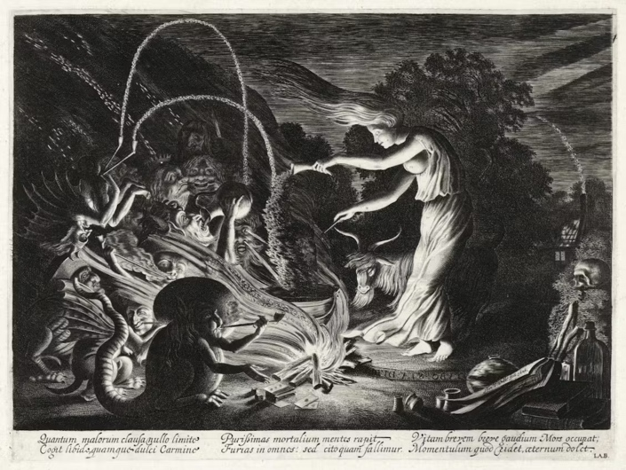
The fearful conduct of alewives was most often depicted in woodcarvings and artwork. The imaging shared similarities with Mother Louse's and Elynour Rummying's portraits, participating in frightful behaviour. The anthology The History of Witches and Wizards recounts the trials in England and New England and publicizes cartoons about witches. The illustrations include depictions of witches in traditional brewing attire, fitted with brooms and cauldrons, much like Brewsters initially used. They prepare brews as offerings that they describe as devilish. These fearful behaviours occur daily in an alehouse but now have new meaning. If a woman facilitates them, one should be suspicious of witchcraft. Similar conduct is conceived in the artwork by Jan van de Velde, titled The Sorceress. Unlike the woodcarvings spoken of previously, The Sorceress is artwork employing realism. The protagonist, a woman, stands above a cauldron as familiars and devils stir around her, seen in figure 7. They are playing cards, games, and smoking. The image has a sinister sentiment, but the characters act no different from the many depictions of men around a tavern table. As described like all the others, the illustrations of witches villainize behaviour that is seemingly normal for men in a tavern. Drinking, brewing, games, and smoking are all permissible conduct if done by the right people in the proper atmosphere. The use of these actions in artwork tactically targets women who break the stereotypes of drinking and brewing, the Alewife. Not only was this used in propaganda artwork, but against women during the trials and in prosecution
Figures 4–6. Scenes of witchcraft from early modern woodcut illustrations.
Figure 4: Witches feasting in a celebratory scene.
Figure 5: Witches flying on broomsticks.
Figure 6: Witches dancing with devils.
All illustrations from The History of Witches and Wizards: Giving a True Account of All Their Tryals in England, Scotland, Swedeland, France, and New England; with Their Confession and Condemnation, by W. P. (London: T. Norris, 1720), 6, 17, 36. Public domain. Courtesy of Wellcome Collection.
Figure 7. Heks (The Sorceress) by Jan van de Velde II, 1626. Engraving depicting a witch by a cauldron, surrounded by monsters and a strong wind. Rijksmuseum. Public domain. Courtesy of the Rijksmuseum. https://id.rijksmuseum.nl/200392803.
Many examples from the witch trials show that alewives' behaviour was often used as justification for prosecution. In the case of Julian Cox, a brewed drink was considered an offering from the devil. Cox succumbed to temptation and participated in drinking, for which she was accused. The act of women drinking was already widely disapproved of, as reflected in the disdain directed at alewives. While Julian Cox's behaviour was labelled as witchcraft, it mirrored the regular criticism faced by Brewsters. Similarly, New Haven's Elizabeth Godman was suspected of a variety of witchcraft activities, which included hindering the brewing of Beer. Domestic processes were often an outlet for witchcraft actions, such as intentionally spoiling Beer during brewing or "make it 'jump out of the barrill' or disappear altogether." Another "criminal," Mehitabel Downing, had several appearances in court, reported for excessive drinking and "neglecting their children some days and nights, often leaving them alone." In all these cases, traditional drinking and brewing behaviour was put on trial as witchcraft. This effectively strengthened the argument against women in the industry, conflating their work with illicit behaviour.
Furthermore, the cases of Ellinor Hollingsworth, Mary Hale, and Katherine Harrison all employed similar sentiments. These women were convicted for their economic success in tavern keeping, brewing, sales, and innkeeping. These women symbolized wealth's threat to society, tied to the fears mentioned earlier. They were obstacles to men; thus, their behaviour was deemed suspicious. This was a common theme in the trials alongside brewing and drinking malt beverages. Women with economic prosperity were more likely to be tried as witches. Like those punished in regulation, the cucking stool was used to chastise witches, only increasing the similarities. In large, crimes of witchcraft in England and New England had common associations with alewives and Brewsters for their drinking, success, and establishment, as made clear in the patterns and accusations. The stereotypes, artwork, convictions, and humiliation completely altered how society viewed alewives. There was a transition from disgust to fear, from dislike to hatred. Shame was no longer the most significant risk for women who remained in the industry; they became fully immersed in the witch trials. After laws, restriction and defamation had done their all to strip women of their security in the industry, only one liberty remained: safety. The witch trials were the final push. Alewives were hunted, harmed, and even hung for their behaviour. Men had already taken a foothold in the brewing industry, which set it in stone. Being a Brewster or Alewife was no longer safe, as they lost their identity to witches.
In conclusion, men employed all methods to push women out of brewing to gain from the economically advantageous industry. Women dominated the domestic craft, but as growing demand and new additives facilitated industrialization, the opportunity was taken into the hands of others. Men saw the ability to gain from the possible investment, which opened their eyes to what women received from their labour. The autonomy women earned by working as brewers and alehouse keepers threatened patriarchal society and risked taking away leadership and power from the men who held it. The possibility of economic dominance necessitated pushing women out of the brewing enterprise. Their exile from the industry is well documented across artwork and trials villainizing their behaviour, instituting their new history. Their foundation of brewing was rewritten, hidden from the scrutiny they faced as they were pushed out. Through the enactment of the legislature, strict regulation, violent punishment, public humiliation, and prosecution, women found themselves ousted from the very the industry they pioneered.

Bibliography

Anon. Elinour Rummin. London, 1794. Woodcut, Letterpress. https://www.britishmuseum.org/collection/object/P_1848-0911-523
Anon. The London and Country Brewer. London: J. and J. Fox. 1736.
Bennett, Judith M. Ale, Beer, and Brewsters in England. New York: Oxford University Press, 1996.
Burton, Kristen. “The Citie Calls for Beere.” Brewery History 150 (2013): 6-15.
Cotton, John. An Abstract of the Lawes of New England. London: Printed for F. Coules, and W. Ley at Paules Chain, 1641.
Eggleston, Edward. The Household History of the United States and Its People, for Young Americans. New York: D. Appleton and Company, 1889. https://lccn.loc.gov/02005793.
Karlson, Carol F. The Devil in the Shape of a Woman. London: W. W. Norton & Company, 1998.
Loggan, David. Mother Louse. London, 1650-72. Line engraving. https://www.britishmuseum.org/collection/object/P_1848-0911-483
Martin, A. Lynn. Alcohol, Sex, and Gender in Late Medieval and Early Modern Europe. New York: Palgrave, 2001.
Mather, Increase. Occasion’d by the Death of that Pious Gentlewoman, Mrs. Mariah Mather. Boston, 1639-1723. https://name.umdl.umich.edu/N01435.0001.001
Skelton, John. "The Tunnyng of Elynour Rummyng." In The Poetical Works of John Skelton, vol. 1, edited by Alexander Dyce, 109-131. Boston: Little, Brown, and Company, 1866. https://www.luminarium.org/editions/elynour.htm.
T. E. The Lawes Resolutions of Womens Rights. London: Printed for John Grove, 1692.
van de Velde, Jan. The Sorceress. Dutch Republic, 1626. Engraving. https://id.rijksmuseum.nl/200392803.
W. P. The History of Witches and Wizards: Giving a True Account of All Their Tryals in England, Scotland, Swedeland, France, and New England; with Their Confession and Condemnation. London: T. Norris, 1720. https://wellcomecollection.org/works/abkab8tq.

John Skelton, "The Tunnyng of Elynour Rummyng," in The Poetical Works of John Skelton, vol. 1, ed. Alexander Dyce (Boston: Little, Brown, and Company, 1866), 109-131. https://www.luminarium.org/editions/elynour.htm.; T. E., The Lawes Resolutions of Womens Rights (London: Printed for John Grove, 1692).
Increase Mather, Occasion’d by the Death of that Pious Gentlewoman, Mrs. Mariah Mather (Boston, 1639–1723).
A. Lynn Martin, Alcohol, Sex, and Gender in Late Medieval and Early Modern Europe (New York: Palgrave, 2001), 19.
Anon., The London and Country Brewer (London: J. and J. Fox, 1736), 5-11.
Martin, Alcohol, Sex, and Gender in Late Medieval and Early Modern Europe, 23.
Martin, Alcohol, Sex, and Gender in Late Medieval and Early Modern Europe, 29.
Kristen Burton, “The Citie Calls for Beere,” Brewery History 150 (2013): 6.
Martin, Alcohol, Sex, and Gender in Late Medieval and Early Modern Europe, 59.
Judith M. Bennett, Ale, Beer, and Brewsters in England (New York: Oxford University Press, 1996), 12.
Bennett, Ale, Beer, and Brewsters in England, 100.
Bennett, Ale, Beer, and Brewsters in England, 104.
Bennett, Ale, Beer, and Brewsters in England, 105.
Burton, “The Citie Calls for Beere,” 7.
T. E., The Lawes Resolutions of Womens Rights, 80.
John Cotton, An Abstract of the Lawes of New England (London: Printed for F. Coules, and W. Ley at Paules Chain, 1641).
Martin, Alcohol, Sex, and Gender in Late Medieval and Early Modern Europe, 68.
Martin, Alcohol, Sex, and Gender in Late Medieval and Early Modern Europe, 67.
Martin, Alcohol, Sex, and Gender in Late Medieval and Early Modern Europe, 67.
Martin, Alcohol, Sex, and Gender in Late Medieval and Early Modern Europe, 67.
John Skelton, "The Tunnyng of Elynour Rummyng," quoted in Ale, Beer, and Brewsters in England, 123.
John Skelton, "The Tunnyng of Elynour Rummyng," quoted in Ale, Beer, and Brewsters in England, 124.
W. P., The History of Witches and Wizards: Giving a True Account of All Their Tryals in England, Scotland, Swedeland, France, and New England; with Their Confession and Condemnation (London: T. Norris, 1720), 1-11.
Carol F. Karlson, The Devil in the Shape of a Woman (London: W. W. Norton & Company, 1998), 23.
Karlson, The Devil in the Shape of a Woman, 7.
Karlson, The Devil in the Shape of a Woman, 98.
Karlson, The Devil in the Shape of a Woman, 146.

